**Application Deployment**

*(Deploy the given React application to a production-ready state)*

**Step-1:**

Create fork of the given repo : [sriram-R-krishnan/devops-build](https://github.com/sriram-R-krishnan/devops-build)

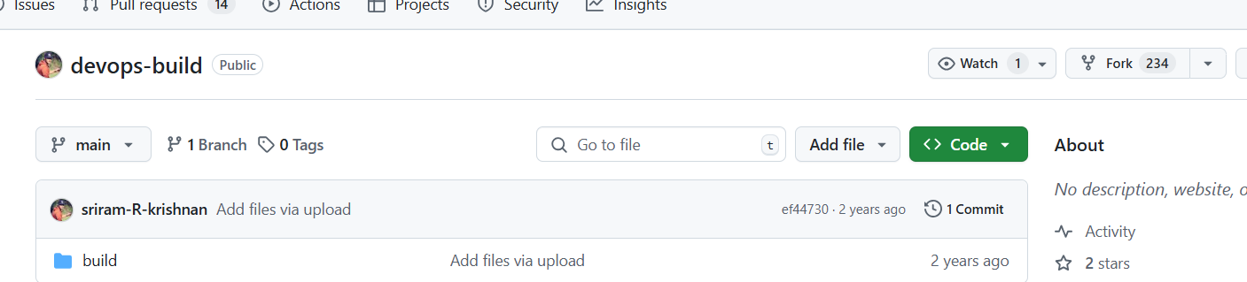

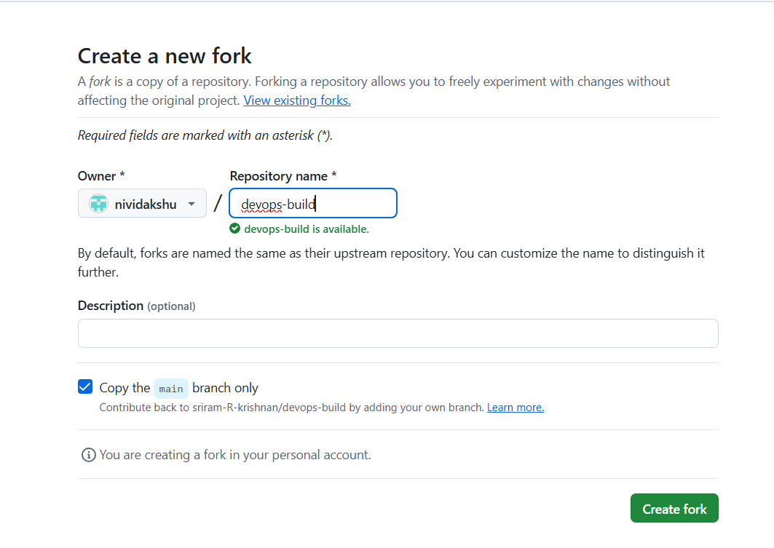

Now clone the github repository,

gitclone <https://github.com/nividakshu/devops-build>

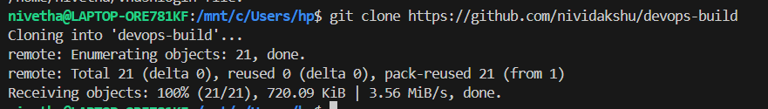

cd devops-build

**Step-2:** Create Dockerfile and Dockercompose.yaml file

Dockerfile

FROM nginx:alpine

COPY build /usr/share/nginx/html

EXPOSE 80

CMD [ "nginx", "-g", "daemon off;" ]

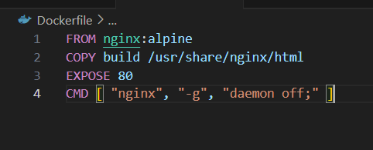

* The -g, is used to override the default nginx configuration.
* Normally nginx will run in the background (daemon mode) without docker , but since we are using in docker, the container must keep running, so we are keeping the nginx running in the foreground to keep the container alive.

docker-compose.yaml

version: “3.8”

services:

  react-app:

    build: .

    container_name: my-reactapp-container

    restart: always

    ports:

      - "80:80"

    networks:

      - app-network

networks:

  app-network:

    driver: bridge

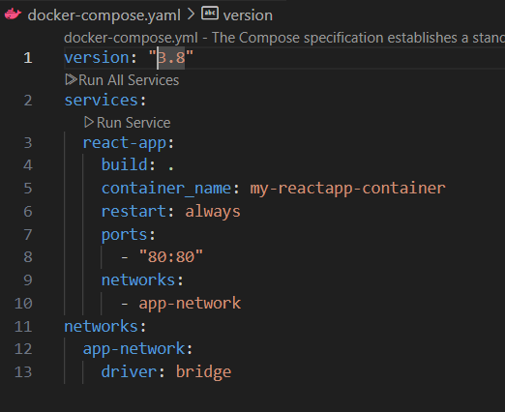

**Step-3:** create build.sh (for building the image and pushing it to concerned docker hub ) ; deploy.sh (for pulling the pushed image from concerned docker hub and deploying it to aws)

build.sh

#!/bin/bash

echo "Current Branch: $BRANCH_NAME"

if [ "$BRANCH_NAME" == "dev" ]; then

docker build -t nividaksha/dev-react-image .

echo "Nivetha@1234" | docker login -u "nividaksha" --password-stdin

docker push nividaksha/dev-react-image:latest

elif [ "$BRANCH_NAME" == "main" ]; then

docker build -t nividaksha/prod-react-image .

echo "Nivetha@1234" | docker login -u "nividaksha" --password-stdin

docker push nividaksha/prod-react-image:latest

fi

chmod +x build.sh

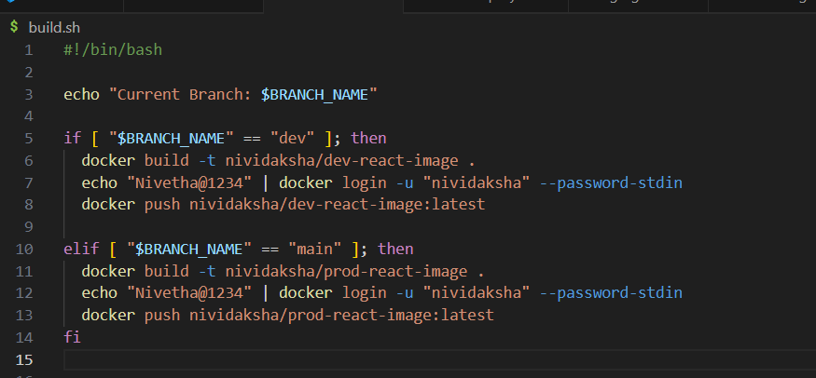

deploy.sh

#!/bin/bash

echo "Deployment Branch: $BRANCH_NAME"

docker stop my-reactapp-container || true

docker rm my-reactapp-container || true

if [ "$BRANCH_NAME" == "dev" ]; then

docker pull nividaksha/dev-react-image:latest

docker run -d -p 80:80 --name my-reactapp-container nividaksha/dev-react-image:latest

elif [ "$BRANCH_NAME" == "main" ]; then

docker pull nividaksha/prod-react-image:latest

docker run -d -p 80:80 --name my-reactapp-container nividaksha/prod-react-image:latest

fi

chmod +x deploy.sh

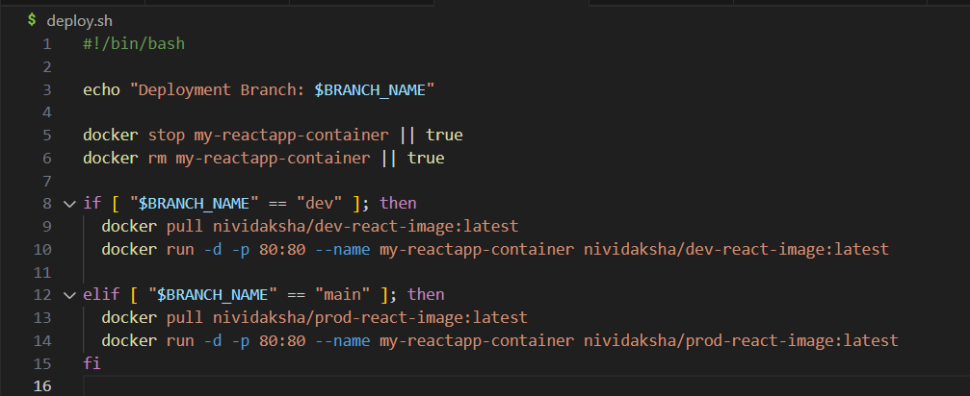

.gitignore

node_modules

build

.env

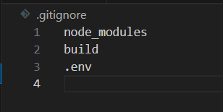

.dockerignore

node_modules

Dockerfile

docker-compose.yml

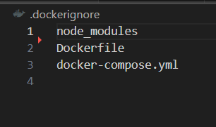

ls -a



**Step-4:** push the files to github repo dev branch

git branch dev

git checkout dev

git add .

git commit -m “docker and deployment scripts”

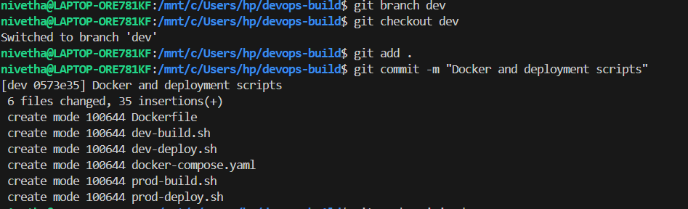

git push origin dev

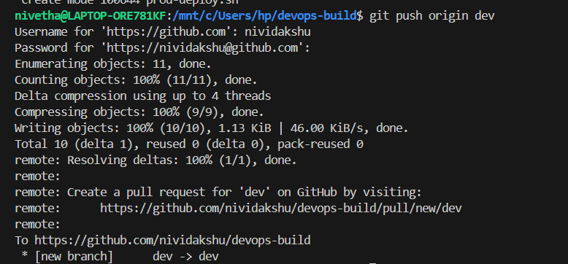

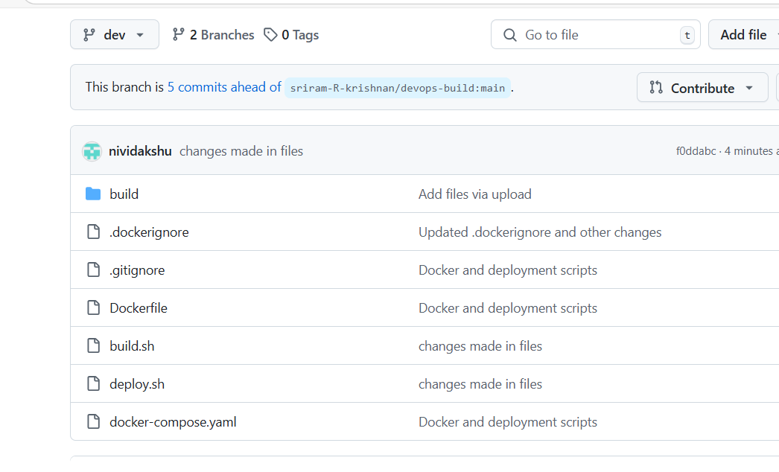

**Step-5:** In docker hub, create repo dev-react-image– public ; prod-react-image– private

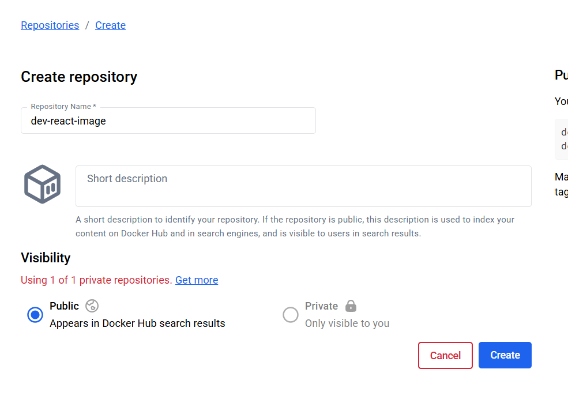

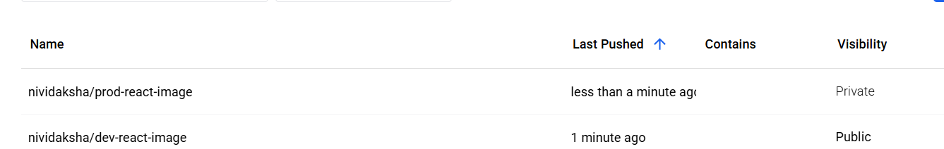

**Step-6:** Launch ec2 instance – chosen ubuntu machine and install jenkins

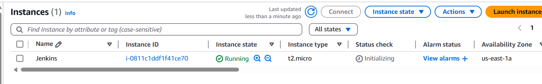

edit inbound rules as below

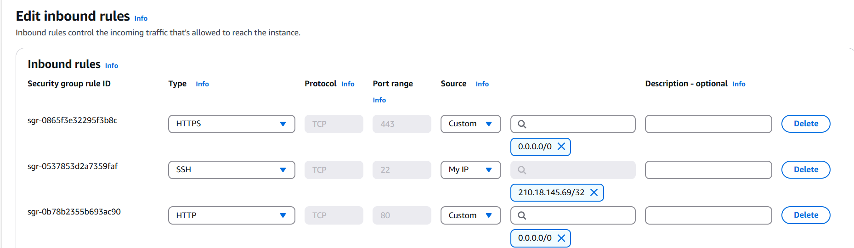

connecting via ec2 instance connect

sudo apt update

sudo apt install fontconfig openjdk-17-jre

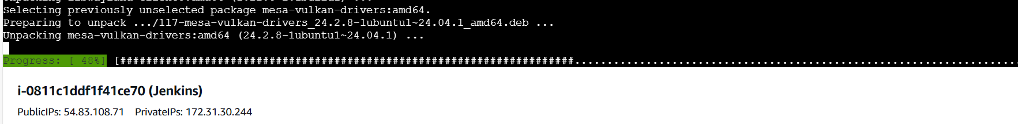

sudo wget -O /usr/share/keyrings/jenkins-keyring.asc \

https://pkg.jenkins.io/debian-stable/jenkins.io-2023.key

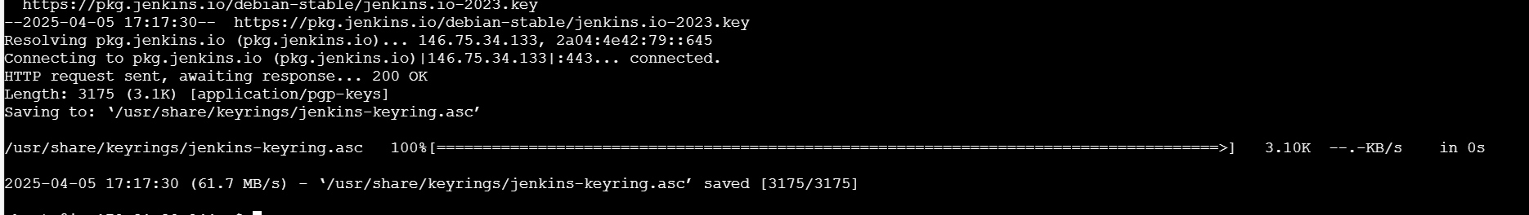

echo "deb [signed-by=/usr/share/keyrings/jenkins-keyring.asc]" \

https://pkg.jenkins.io/debian-stable binary/ | sudo tee \

/etc/apt/sources.list.d/jenkins.list **>** /dev/null

sudo apt update

sudo apt-get install jenkins

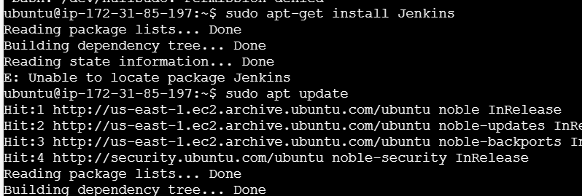

sudo systemctl enable jenkins

sudo systemctl start jenkins

Access Jenkins via [http:// 54.83.108.71:8080](http://52.205.205.129:8080)

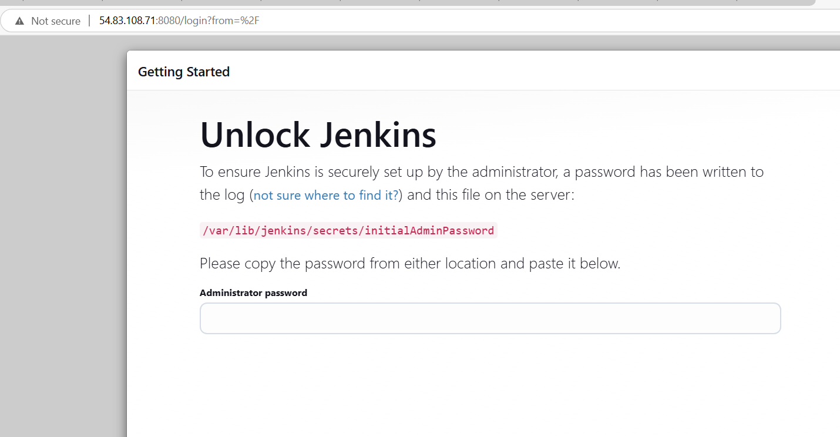

sudo cat /var/lib/jenkins/secrets/initialAdminPassword



copy paste the initial admin pw

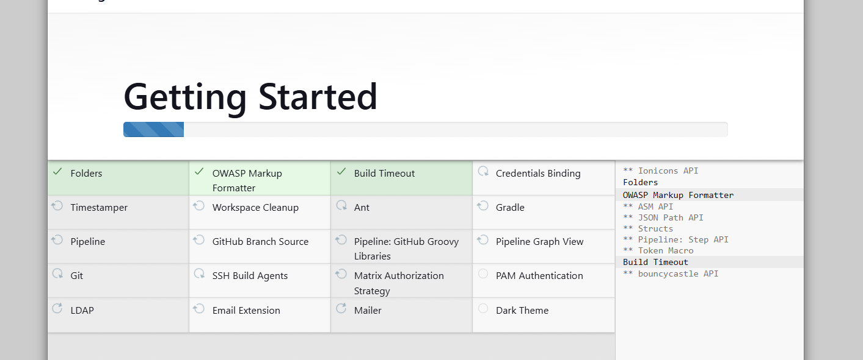

give the credentials

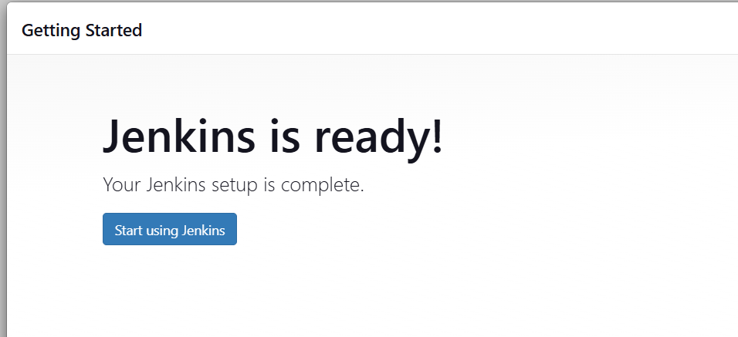

Install docker plugin >> manage Jenkins >> plugin >>Available plugins

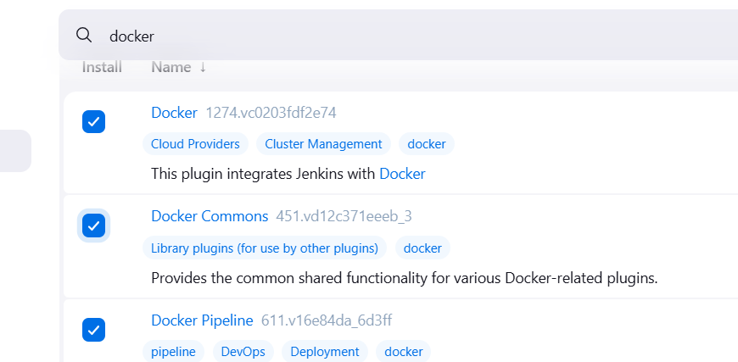

Check whether git, pipeline is installed or install it.

Install SSH Agent

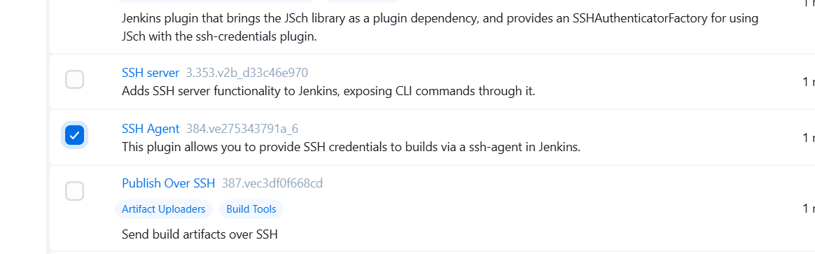

Install Github integration

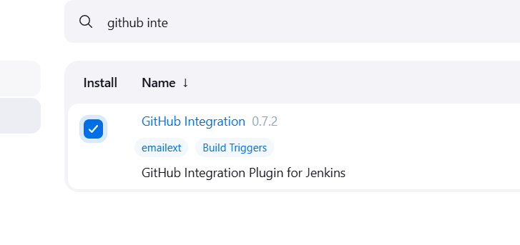

Multibranch pipeline

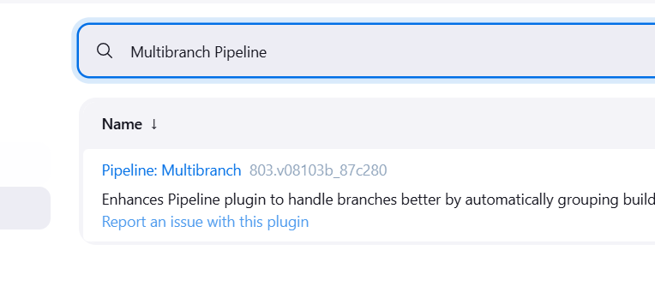

**Step 7:** add the webhook in the github so that when push occurs in the git, webhook trigger Jenkins to automate the process.

Goto githubrepo > settings > webhooks>add webhook>Jenkins url > application/json>just the push event

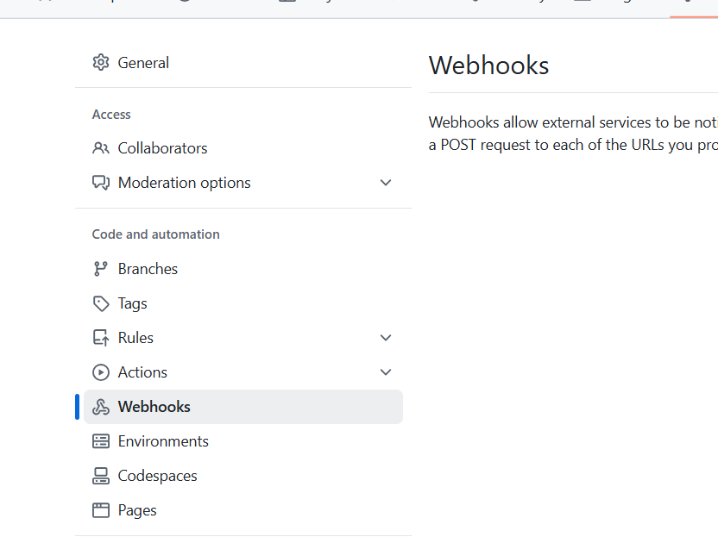

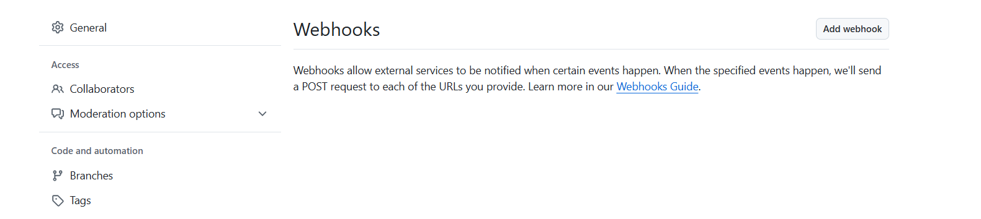

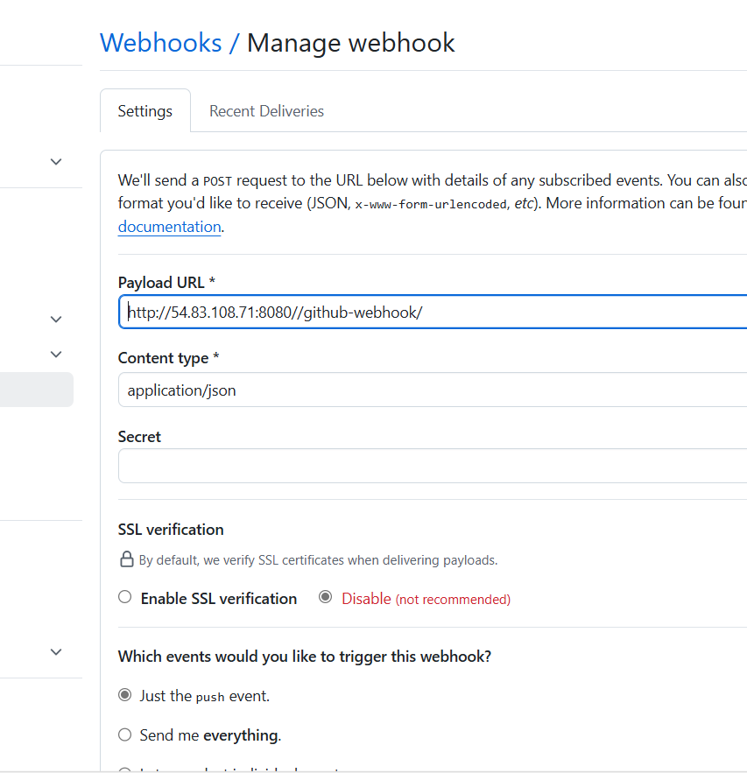

**Step 8:** Create multibranching pipeline in jenkins

Creating pipeline job in Jenkins, so that when push occurs in dev branch, webhook trigger will trigger Jenkins to run build.sh file. Upon running, my Image will be built and pushed to docker hub dev repo which will be pulled and deployed. The same way when merged with main and push occurs, it will be pushed to prod repo in docker hub which will be pulled and deployed.

For Multibranching pipeline, we should add pipeline script in Jenkinsfile and push it to github repo since we cannot add script like we do in regular pipeline in Jenkins.

Jenkinsfile

pipeline {

    agent any

    environment {

        BRANCH_NAME = "${env.BRANCH_NAME}"

    }

    stages {

        stage('Checkout') {

            steps {

                checkout scm

            }

        }

        stage('Execution permission to scripts') {

            steps {

                sh '''

                chmod +x build.sh

                chmod +x deploy.sh

                '''

            }

        }

        stage('Build & Push Docker Image') {

            steps {

                sh './build.sh'

            }

        }

        stage('Pull the pushed image and Deploy to EC2') {

            steps {

sh '''

scp -o StrictHostKeyChecking=no -i /var/lib/jenkins/.ssh/Nivetha.pem deploy.sh ubuntu@54.83.108.71:/home/ubuntu/

ssh -o StrictHostKeyChecking=no -i /var/lib/jenkins/.ssh/Nivetha.pem ubuntu@54.83.108.71 "BRANCH_NAME=$BRANCH_NAME bash deploy.sh"

'''            }

        }

    }

}

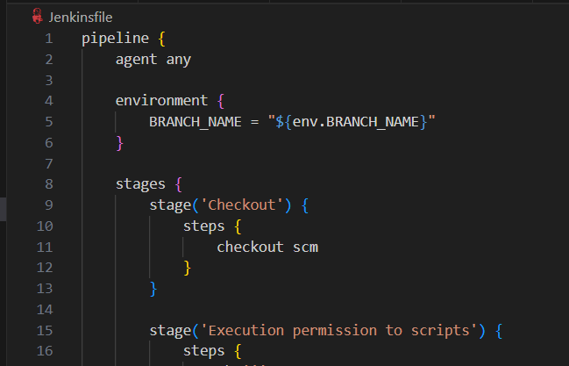

Push it to all branches in git hub

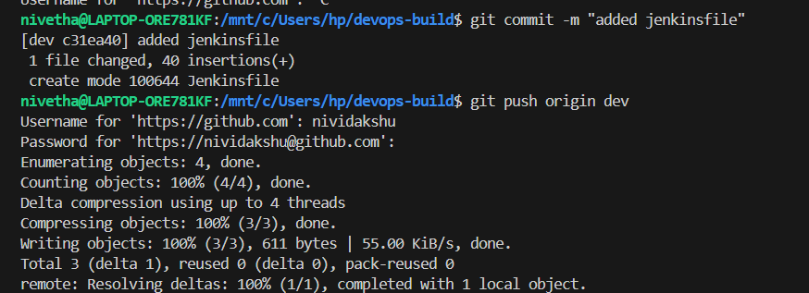

Create a my-reactapp - Multibranch pipeline in jenkins

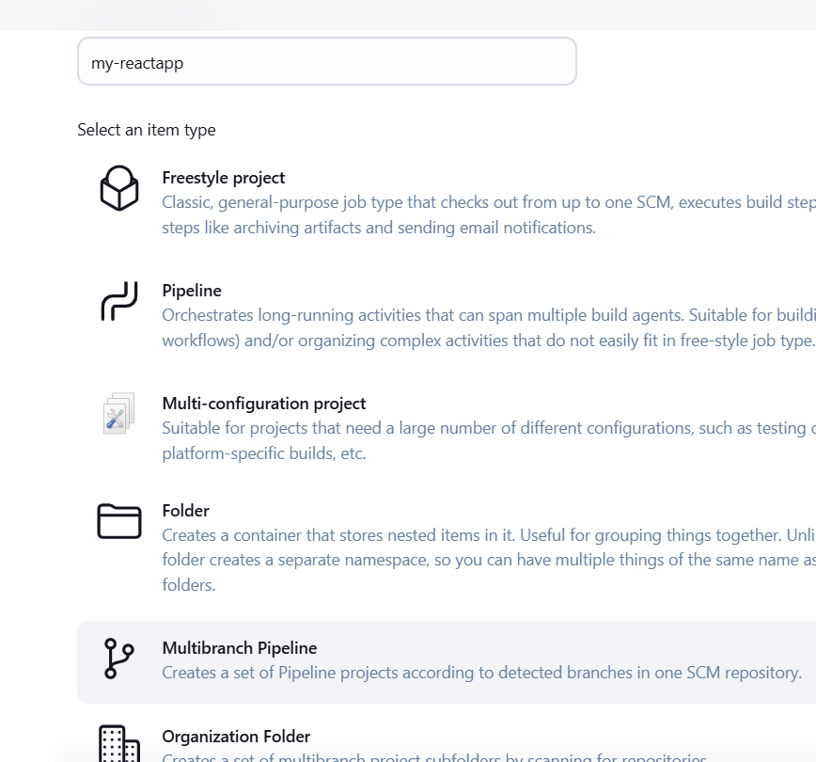

Choose git hub under branch source and give the git hub url

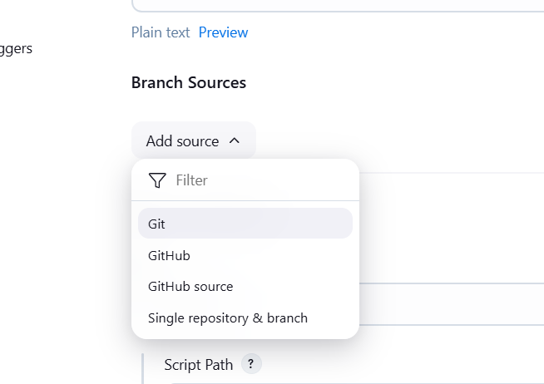

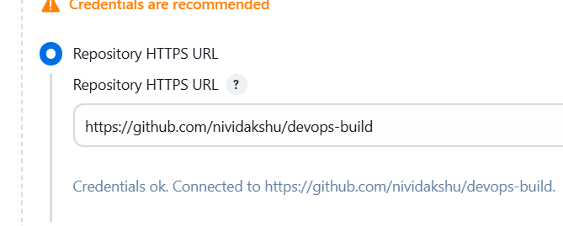

Enable scan repo triggers

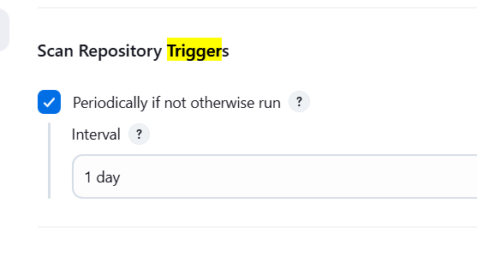

Then save.

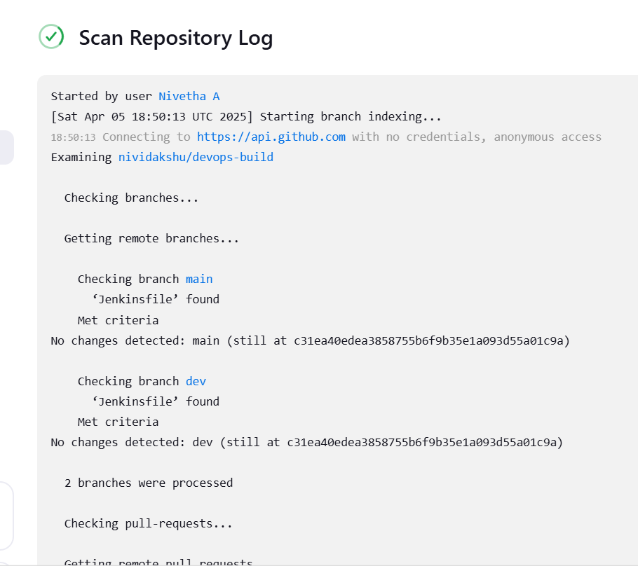

**Step 9:** Install docker on ec2

sudo apt update

sudo apt install -y docker.io

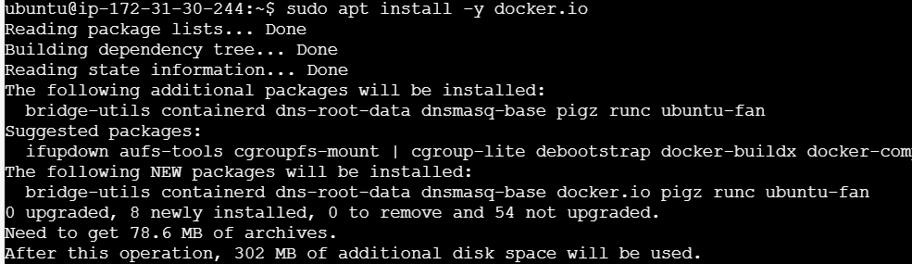

sudo systemctl start docker

sudo systemctl enable docker

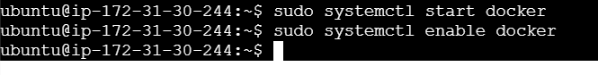

sudo usermod -aG docker Jenkins -- we are creating Jenkins user in docker because Jenkins has to configure docker. docker need sudo command to run but Jenkins usually wont be running as root user so we are creating user.

sudo usermod -aG docker ubuntu

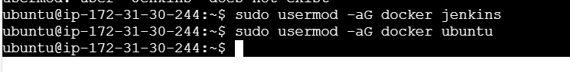

go inside Jenkins , ubuntu and check whether it can access docker

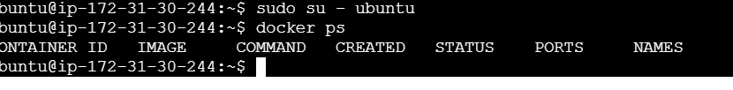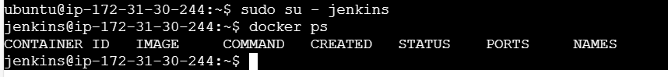

To establish ssh connection,

Go inside jenkins

create directory .ssh

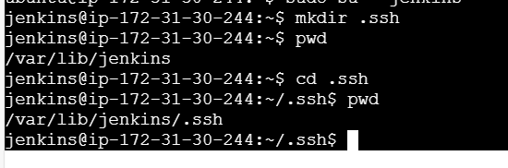

cd .ssh

nano Nivetha.pem

copy the content from our pem file and paste it here

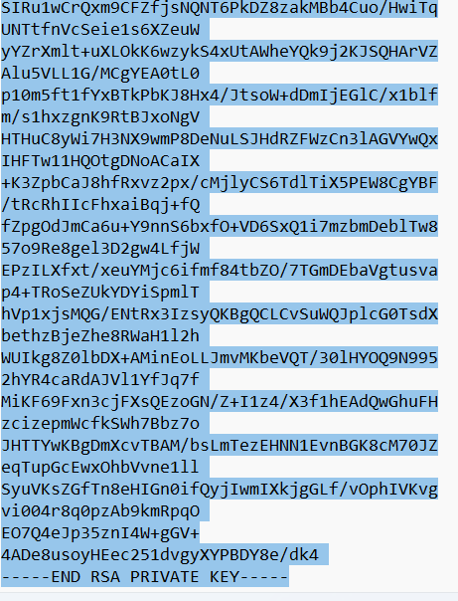

chmod 400 Nivetha.pem

then try ssh- ssh -i /var/lib/jenkins/.ssh/Nivetha.pem ubuntu@54.83.108.71

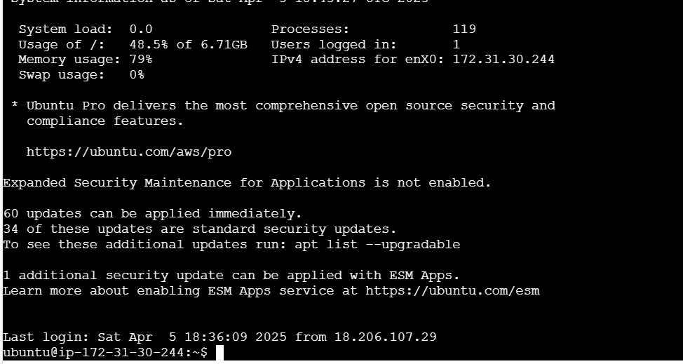

Now Jenkins can ssh to ubuntu machine.

Now push the code

**Step 10:** Verification:

**Test Dev Deployment**

Pushing the code to dev branch

git commit --allow-empty -m "Test Webhook21"

git push origin dev

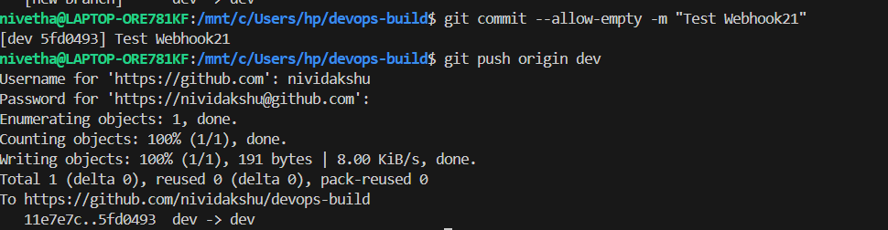

webhook is triggering the push

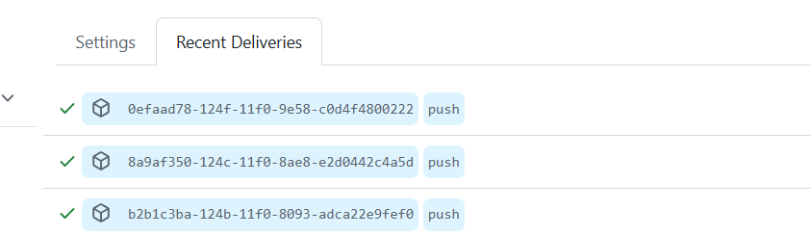

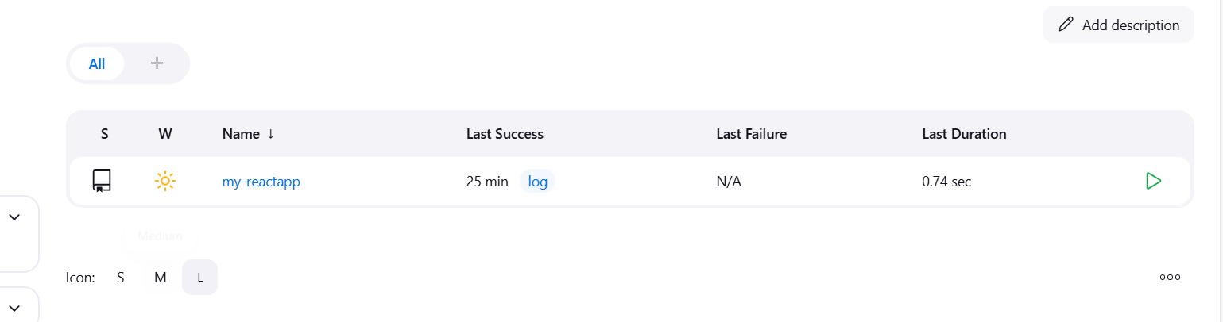

Jenkins is automatically start build and dev repo image has been built and deployed successfully.

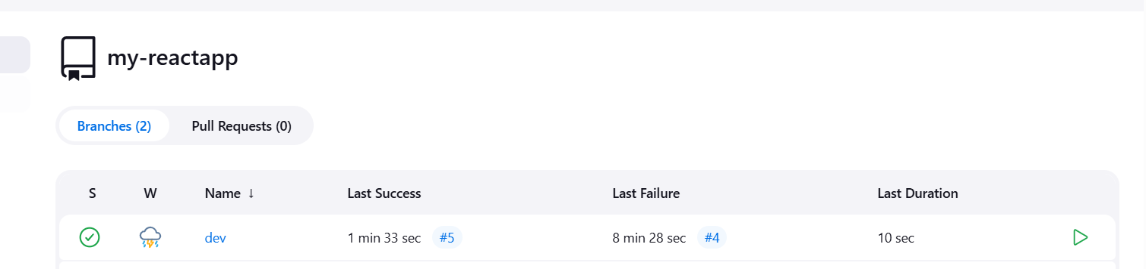

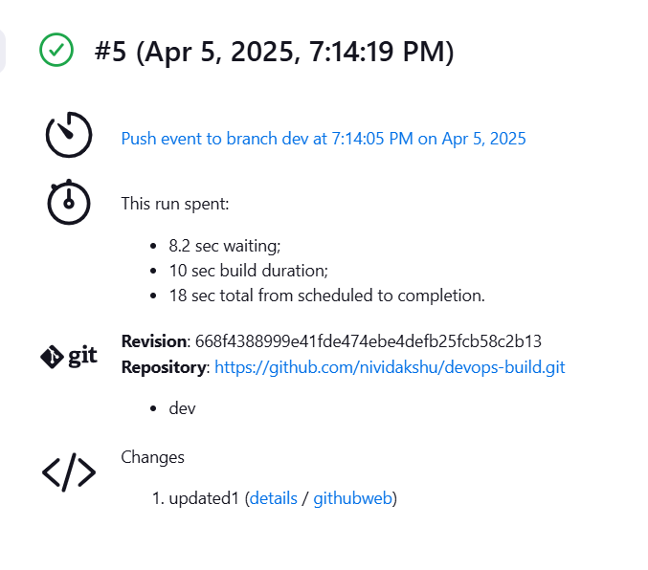

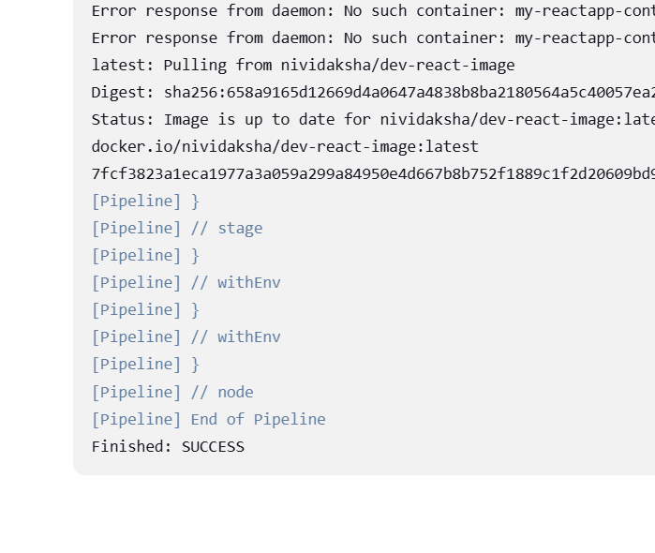

docker ps



Docker hub – Image pushed to dev repo

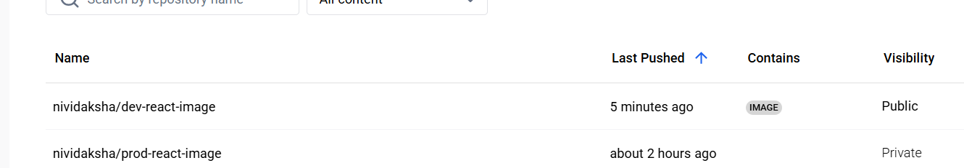

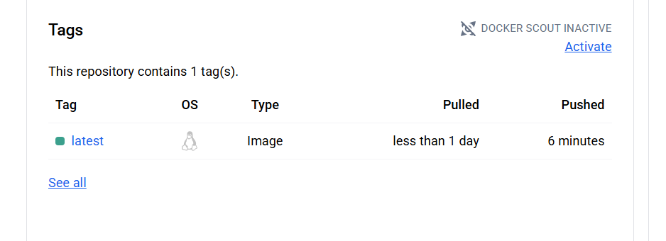

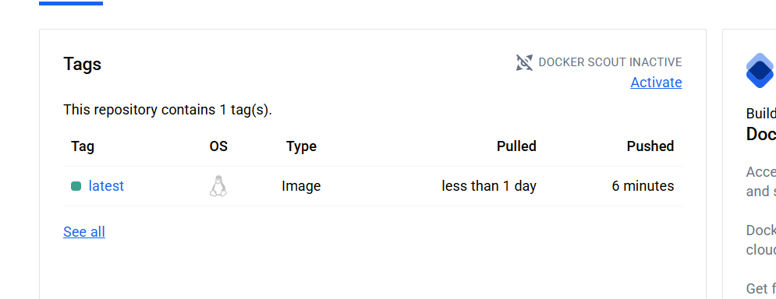

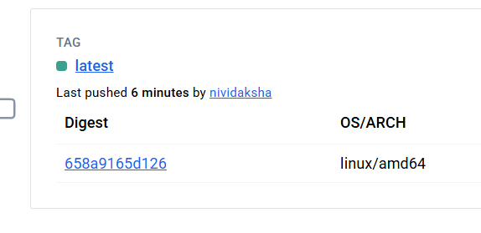

Deployment in ec2 instance

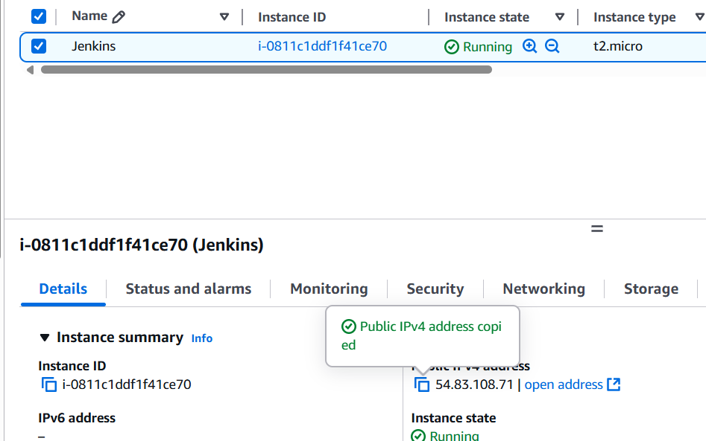

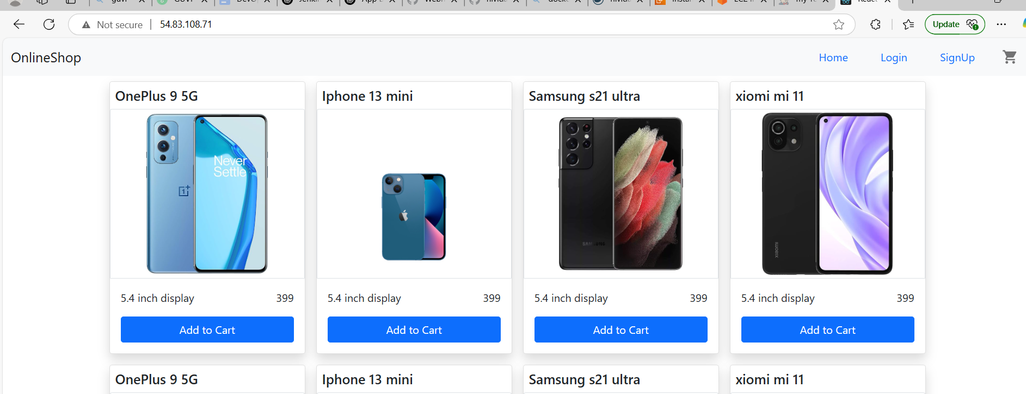

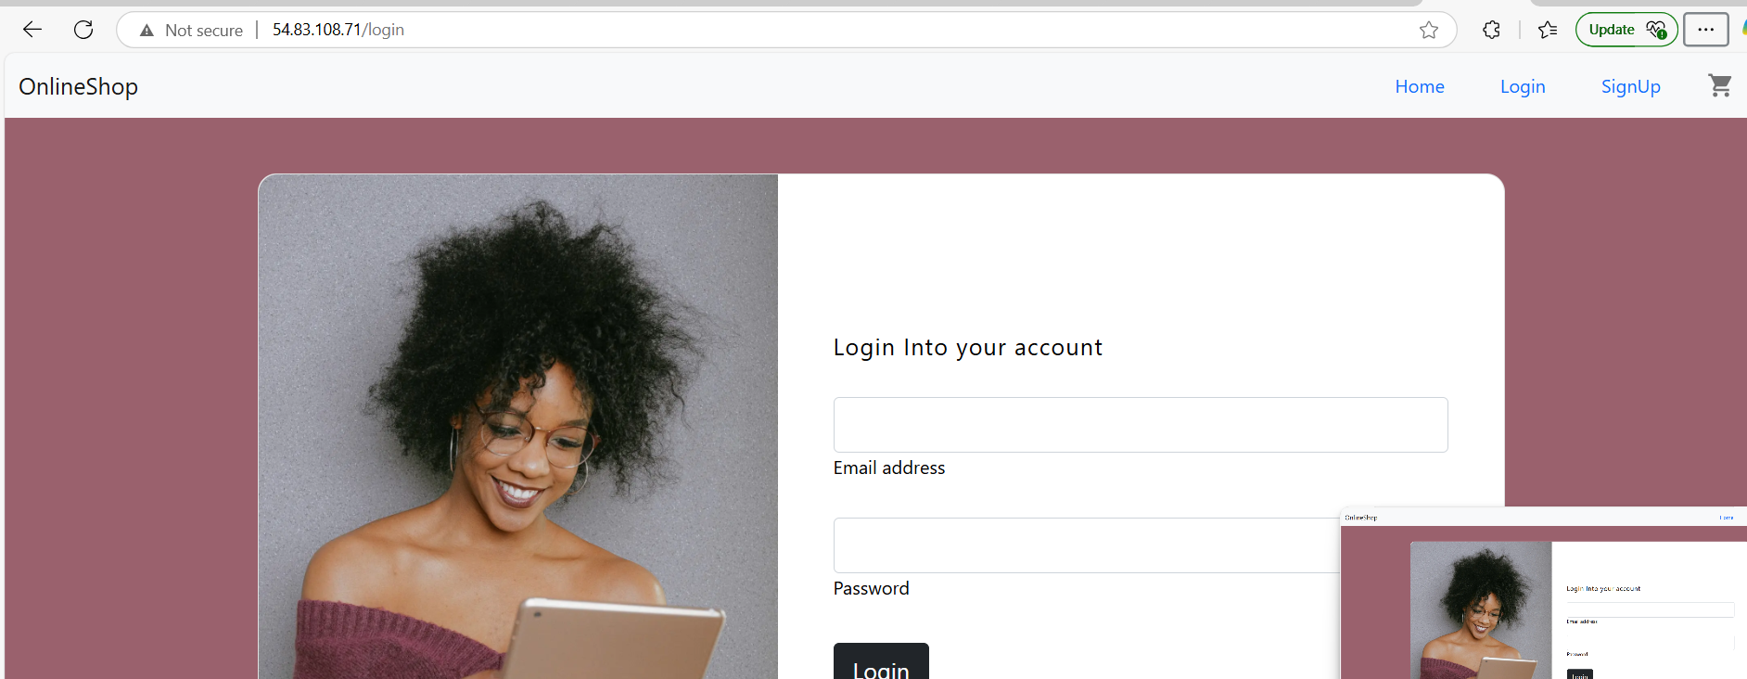

**Test Prod Deployment**

git checkout main

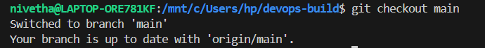

git merge dev

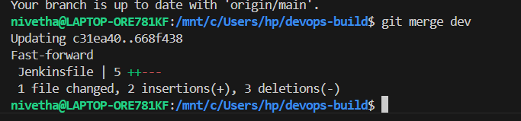

git push origin main

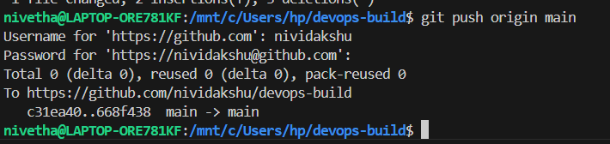webhook triggered

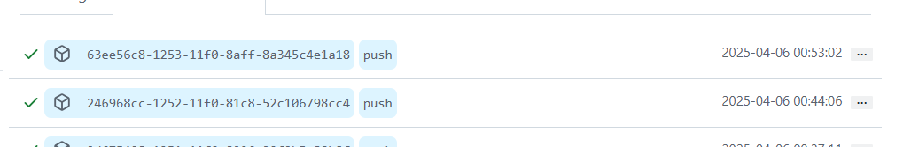

In Jenkins , main branch build also successful

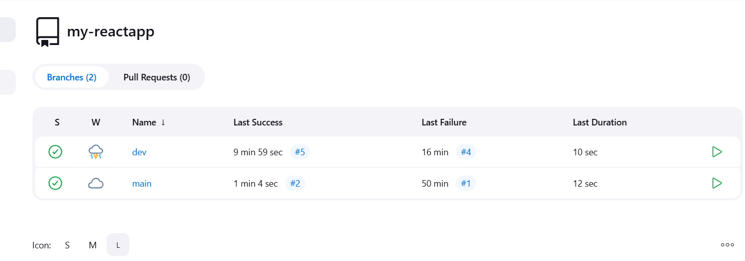

docker ps

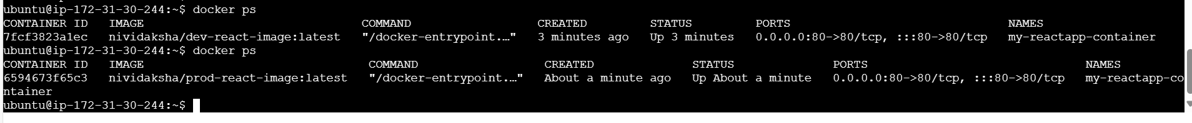

docker hub : image has been pushed to prod

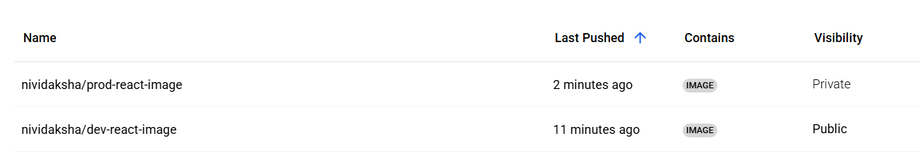

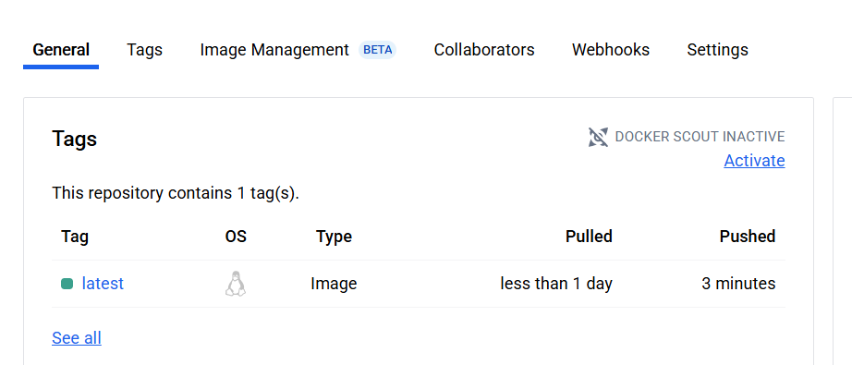

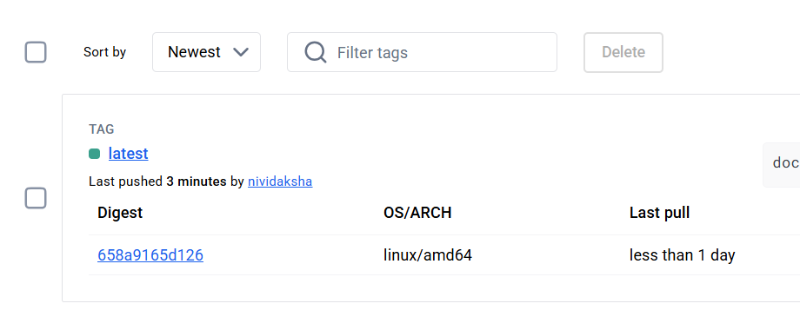

Deployment to EC2:

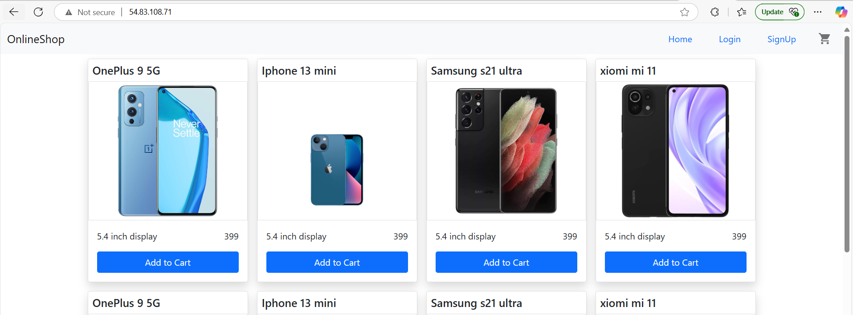

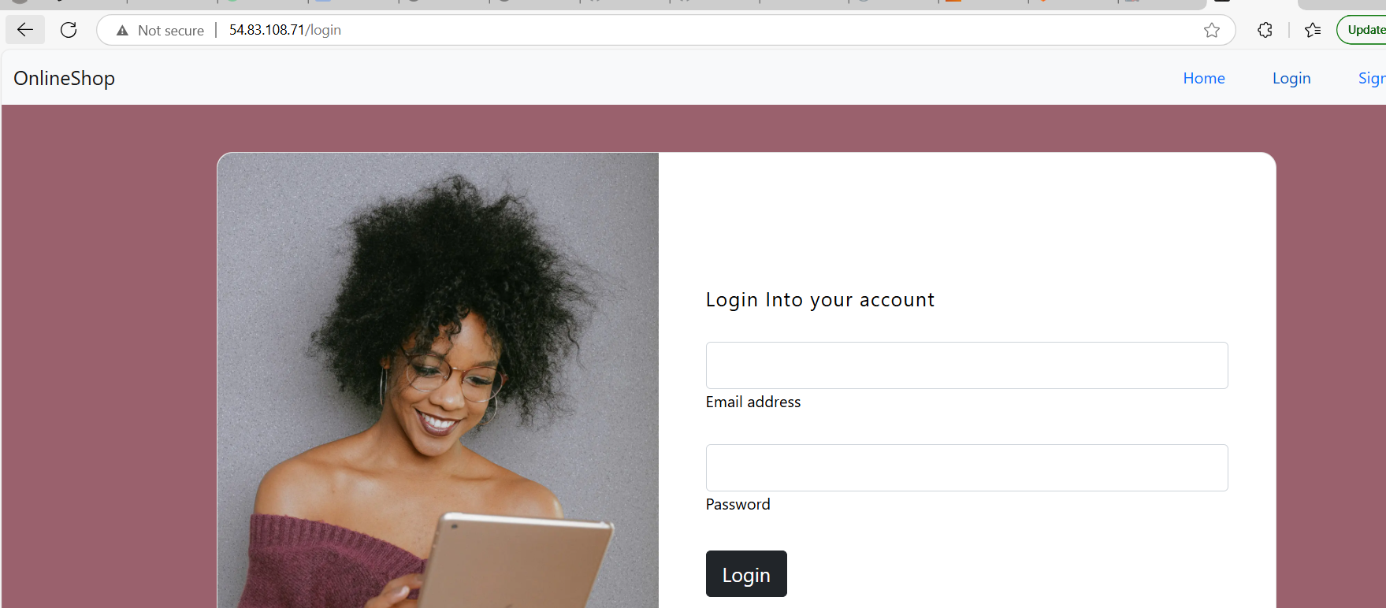

**Step 11:** Monitoring : using Prometheus, node_exporter and alert manager

**Prometheus**

wget https://github.com/prometheus/prometheus/releases/download/v3.3.0-rc.0/prometheus-3.3.0-rc.0.linux-amd64.tar.gz



tar xvzf prometheus-3.3.0-rc.0.linux-amd64.tar.gz

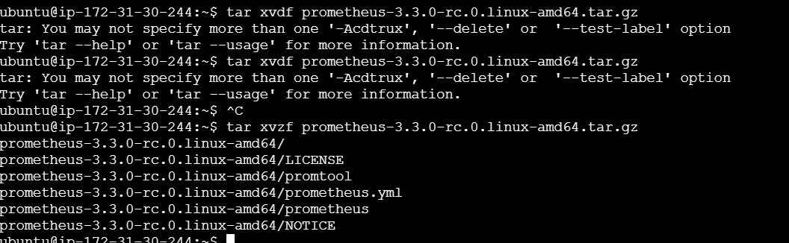

sudo mv prometheus-3.3.0-rc.0.linux-amd64 /etc/Prometheus

**Also download alert manager in same Prometheus doc**

wget <https://github.com/prometheus/alertmanager/releases/download/v0.28.1/alertmanager-0.28.1.linux-amd64.tar.gz>

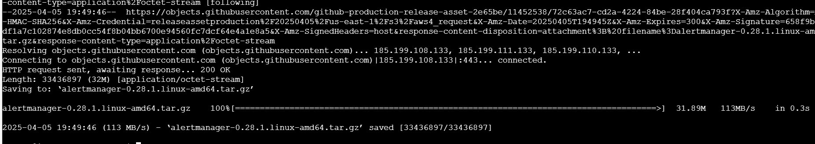

tar xvzf alertmanager-0.28.1.linux-amd64.tar.gz

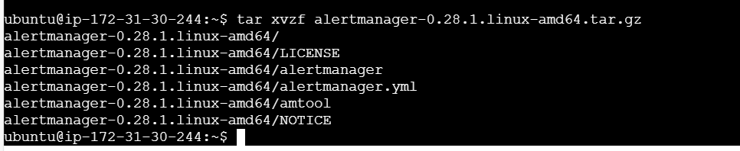

sudo mkdir -p /etc/alertmanager

sudo mv alertmanager-0.28.1.linux-amd64/* /etc/alertmanager/



**Also download node_exporter in same Prometheus doc**

* The reason of downloading node_exporter is, when I run Prometheus without node exporter, it cannot scrape the react app metrics, it was throwing error.
* Prometheus is a **pull-based monitoring system** that collects metrics from targets that expose them in the **Prometheus format** but my ec2 instance was not exposing that metrics to Prometheus. Also our react app is a front end app and it is not generating any metrics , so Prometheus cannot scrape react app metrics in the required format.
* To overcome this installing node_exporter , this exposes the metrics in Prometheus format so Prometheus scrape node exporter and monitor the metrics like health.

Wget <https://github.com/prometheus/node_exporter/releases/download/v1.9.1/node_exporter-1.9.1.linux-amd64.tar.gz>

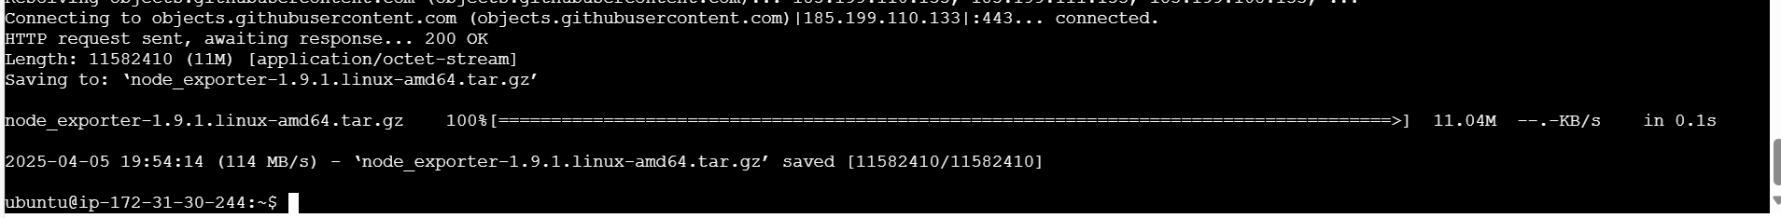

tar xvzf node_exporter-1.9.1.linux-amd64.tar.gz

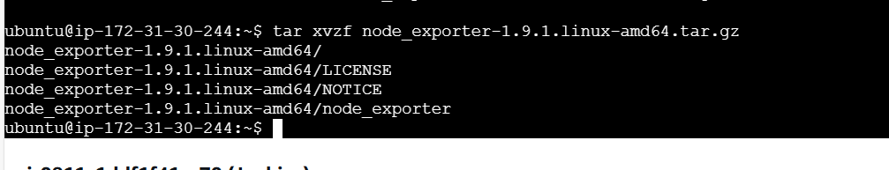

sudo mv node_exporter-1.9.1.linux-amd64 /etc/node_exporter



cd /etc

cd node_exporter

./node_exporter &

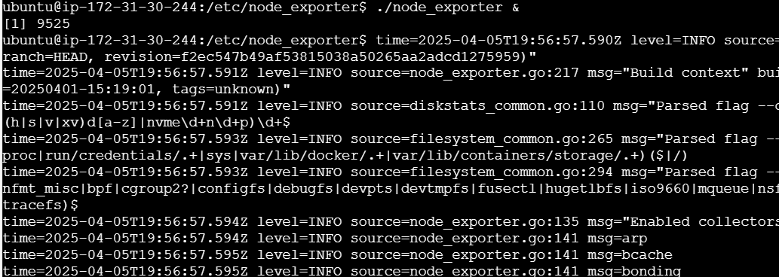

Note the Port number - 9100

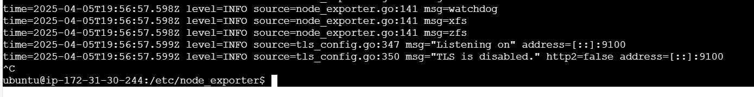

Verify it is running or not using http://54.83.108.71:9100

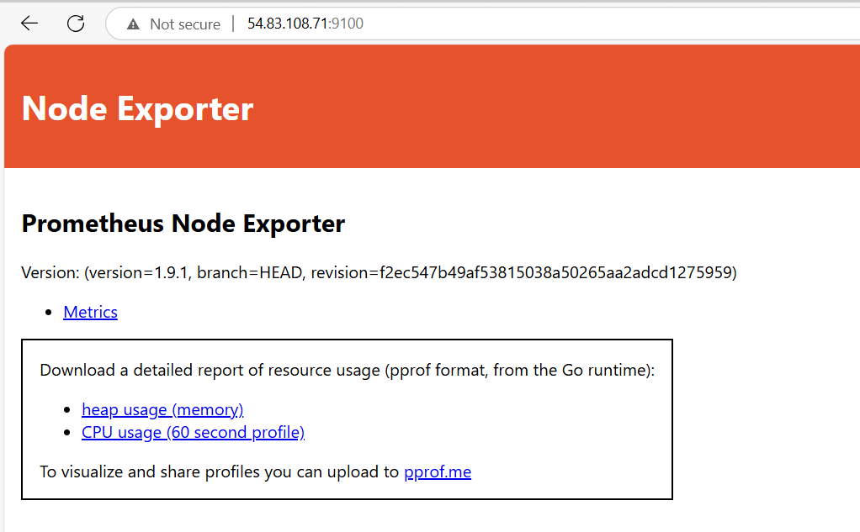

Now go to Prometheus.yaml file

cd /etc

cd Prometheus

vi prometheus.yml

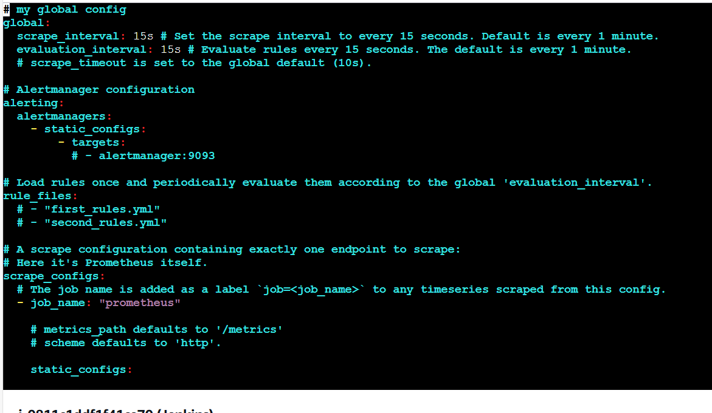

modify – add alertmanager port

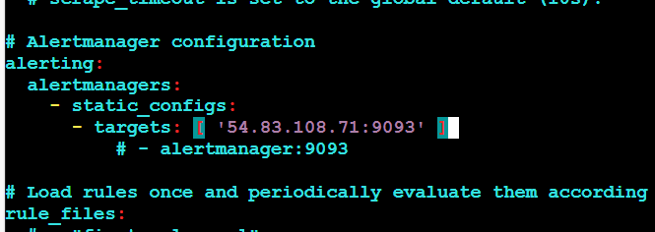

add alert.rules.yml

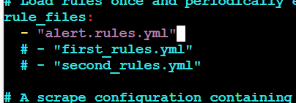

Add the below job

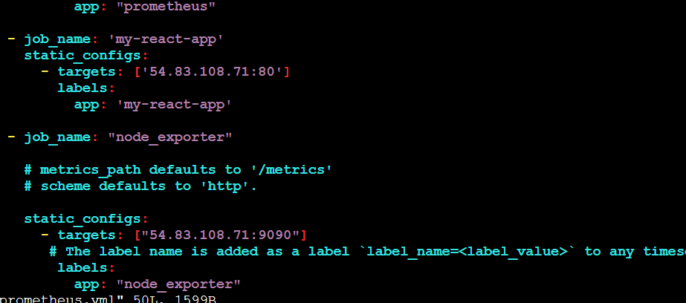

then save and quit

cd /etc/Prometheus

sudo nano alert.rules.yml



groups:

- name: ApplicationAlerts

rules:

- alert: ApplicationDown

expr: up{app="my-react-app"} == 0

for: 1m

labels:

severity: critical

annotations:

summary: "Application is down"

description: "The application {{ $labels.app }} is not responding."

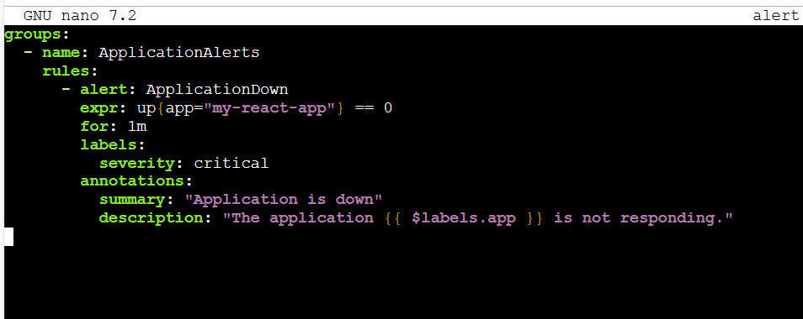

cd alertmanager

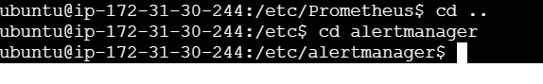

Before editing alert manager yaml, go to gmail and generate app password,

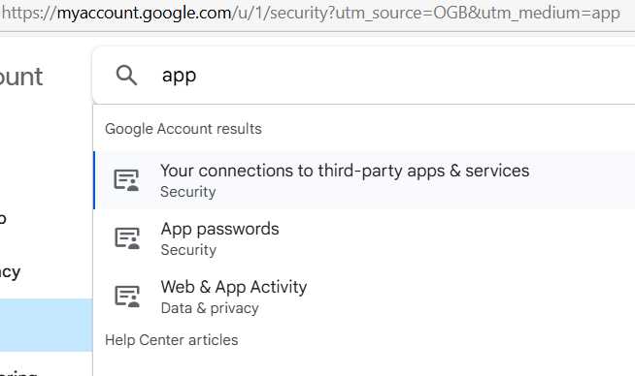

My app pw : enwv pqvn lxbt zalv

vi alertmanager.yml

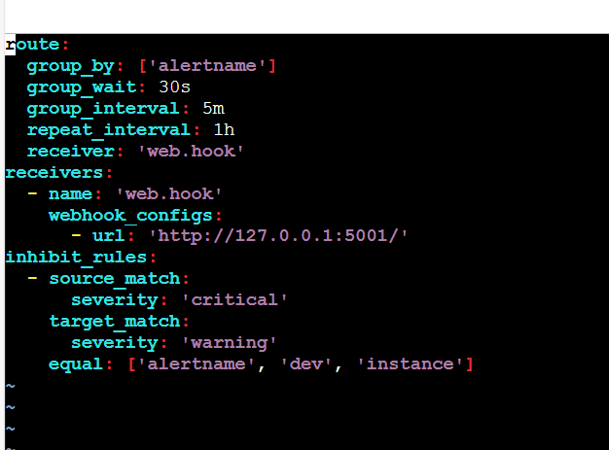

Here the webhook config is given, we can add email config alongside or delete webhook and add email config.

Modify

Add the below content

route:

receiver: "email"

receivers:

- name: "email"

email_configs:

- to: "nivethadhaksha@gmail.com"

from: "nivethadhaksha@gmail.com"

smarthost: "smtp.gmail.com:587"

auth_username: "nivethadhaksha@gmail.com"

auth_password: "enwv pqvn lxbt zalv"

require_tls: true

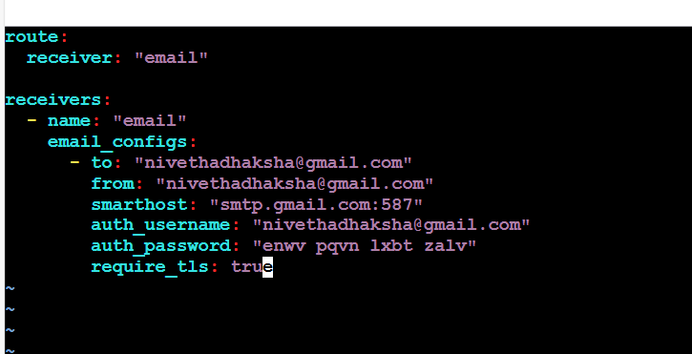

Save

Here auth pw can be set as env variable as well for security purpose

auth_password: "{{ env.EMAIL_PASSWORD }}"

export EMAIL_PASSWORD="enwv pqvn lxbt zalv"

Now **prometheus.yml and alert.rules.yml ➝ prometheus directory.**

**alertmanager.yml ➝ alertmanager directory.**

**Node_exporter ➝ node_exporter directory**

Starting Prometheus

./prometheus --config.file=prometheus.yml &

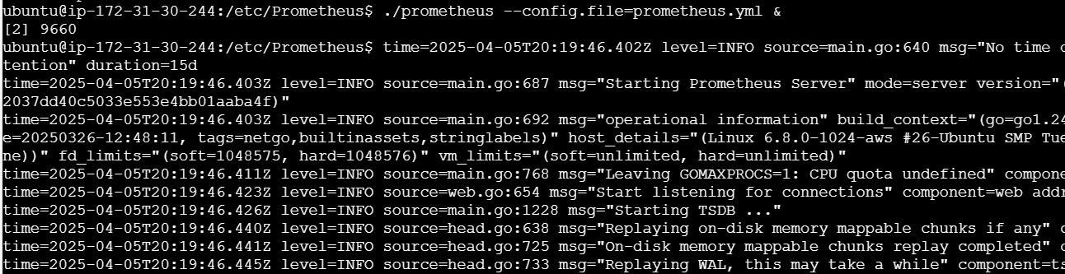

Cd etc

Cd alertmanager

sudo mkdir -p /etc/alertmanager/data

sudo chown -R ubuntu:ubuntu /etc/alertmanager/data

we are giving alertmanager permission to create the data



./alertmanager --config.file=alertmanager.yml &

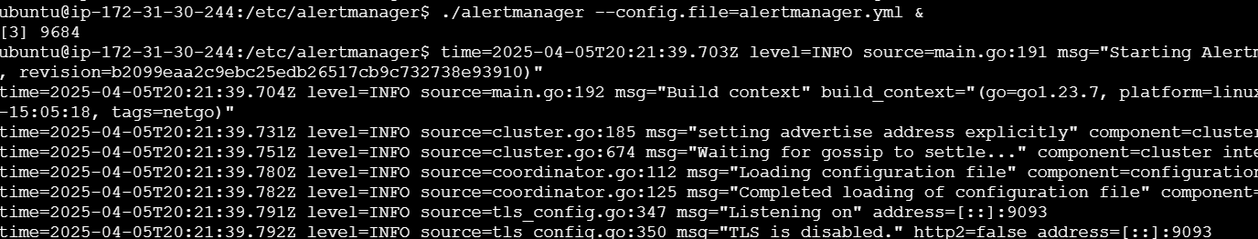

Restarting Prometheus

Ps -ef | grep Prometheus

Kill 9660

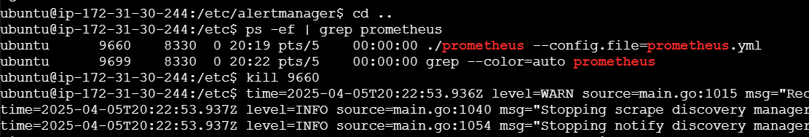

Cd Prometheus

Running it again

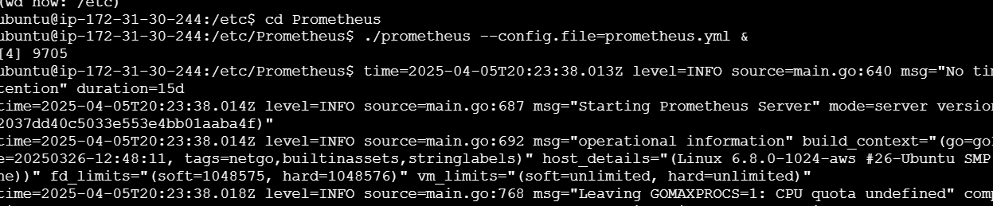

**Prometheus url**

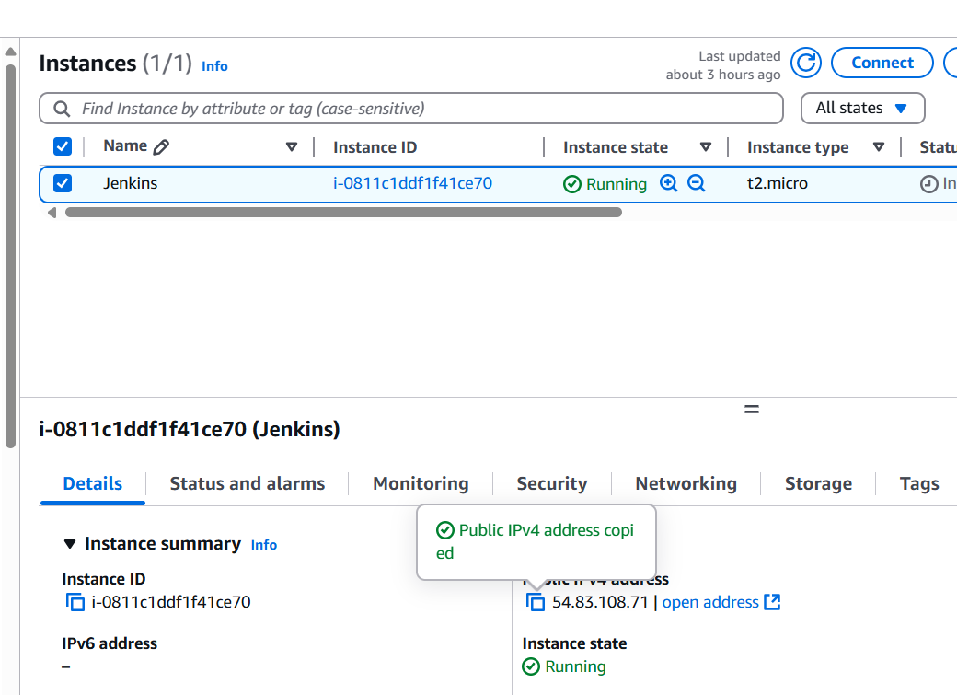

<http://54.83.108.71:9090/>

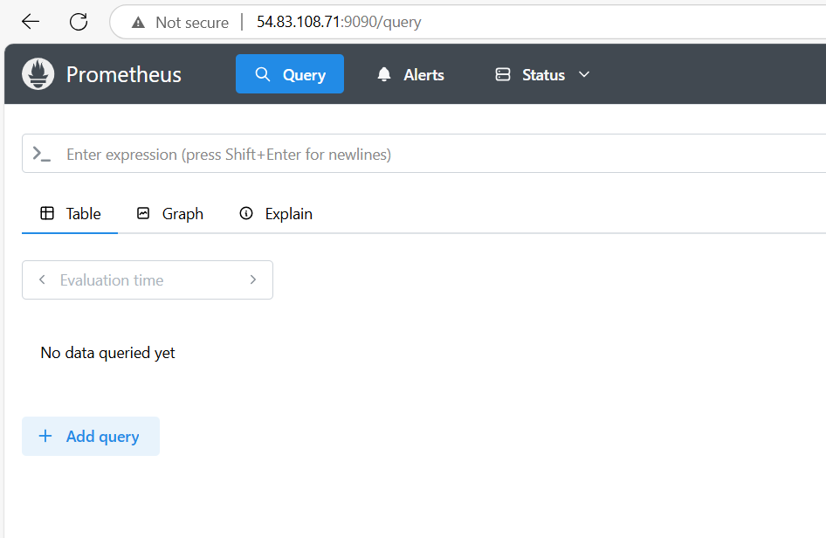

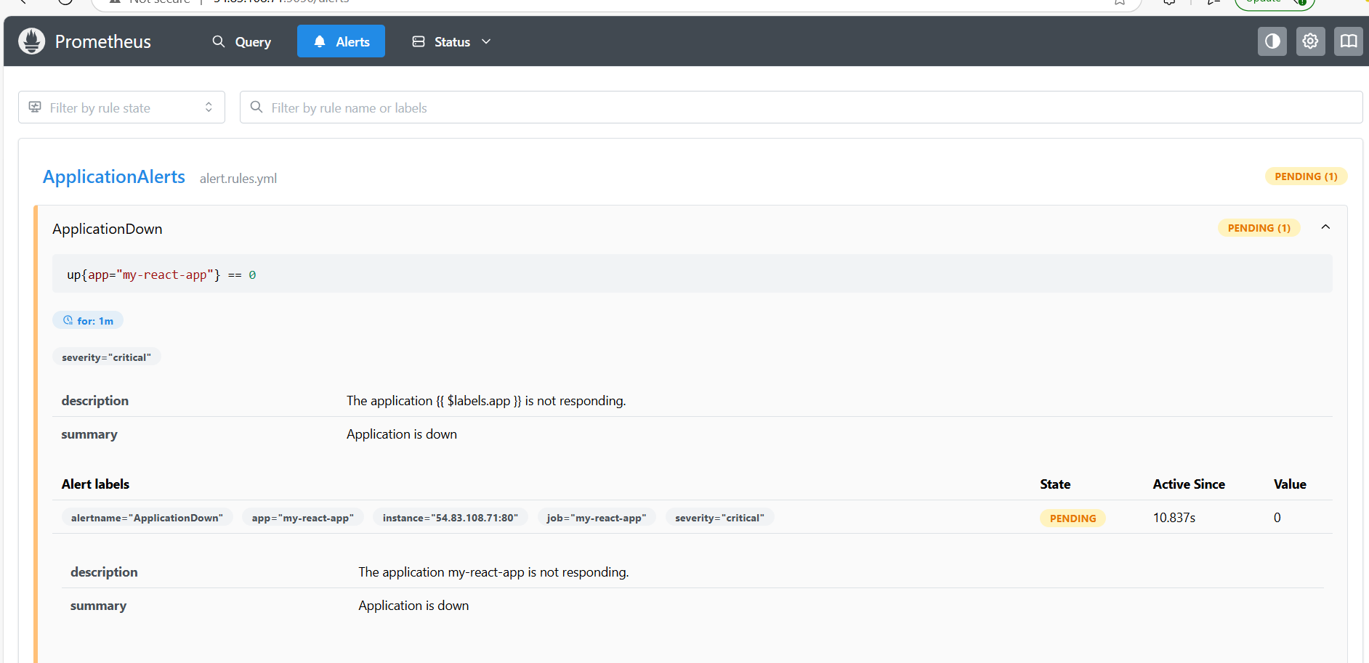

Choose status >> target health

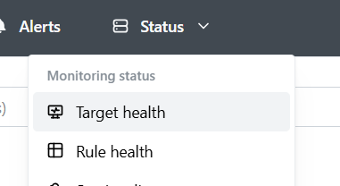

Monitoring the health

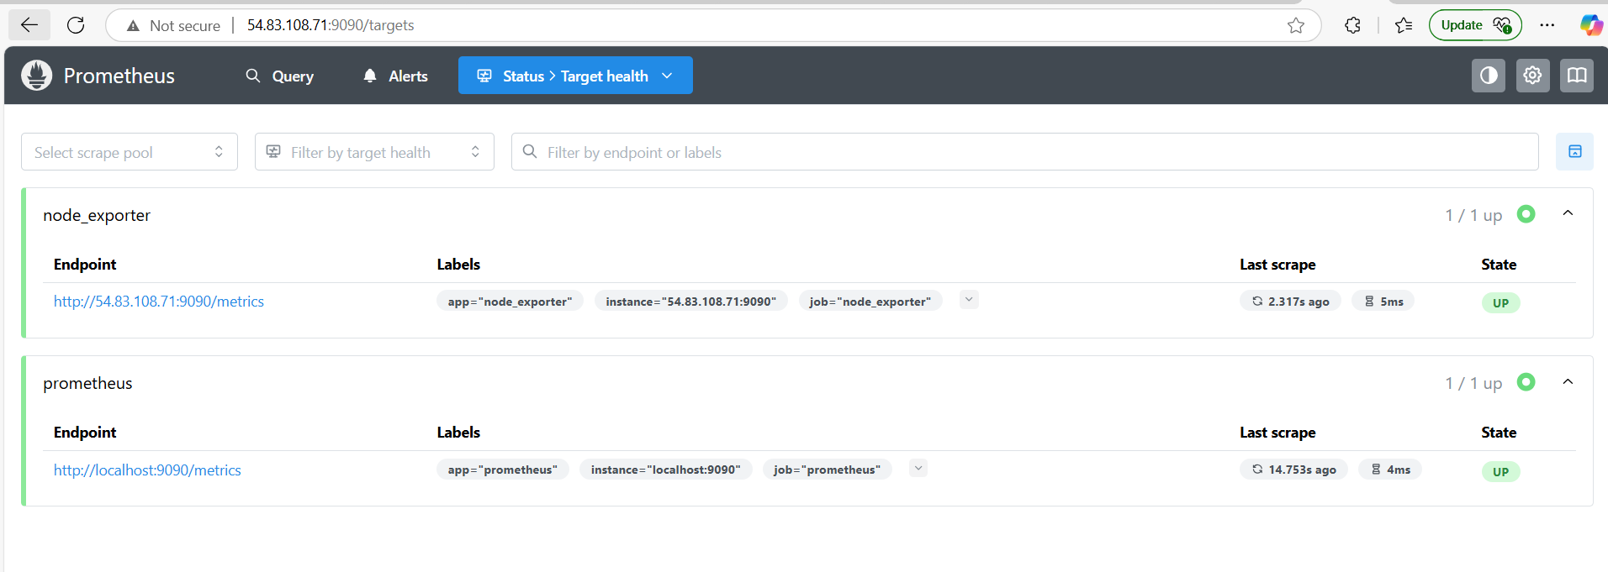

**Alertmanager url**

<http://54.83.108.71/:9093/>

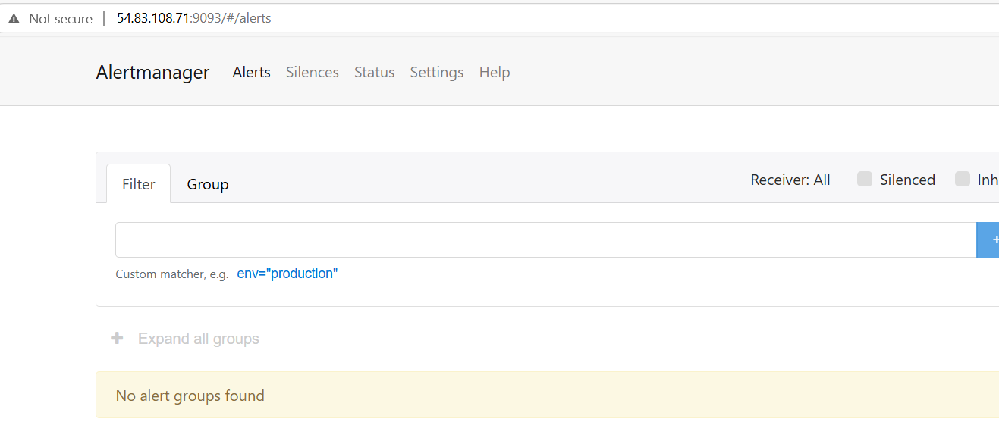

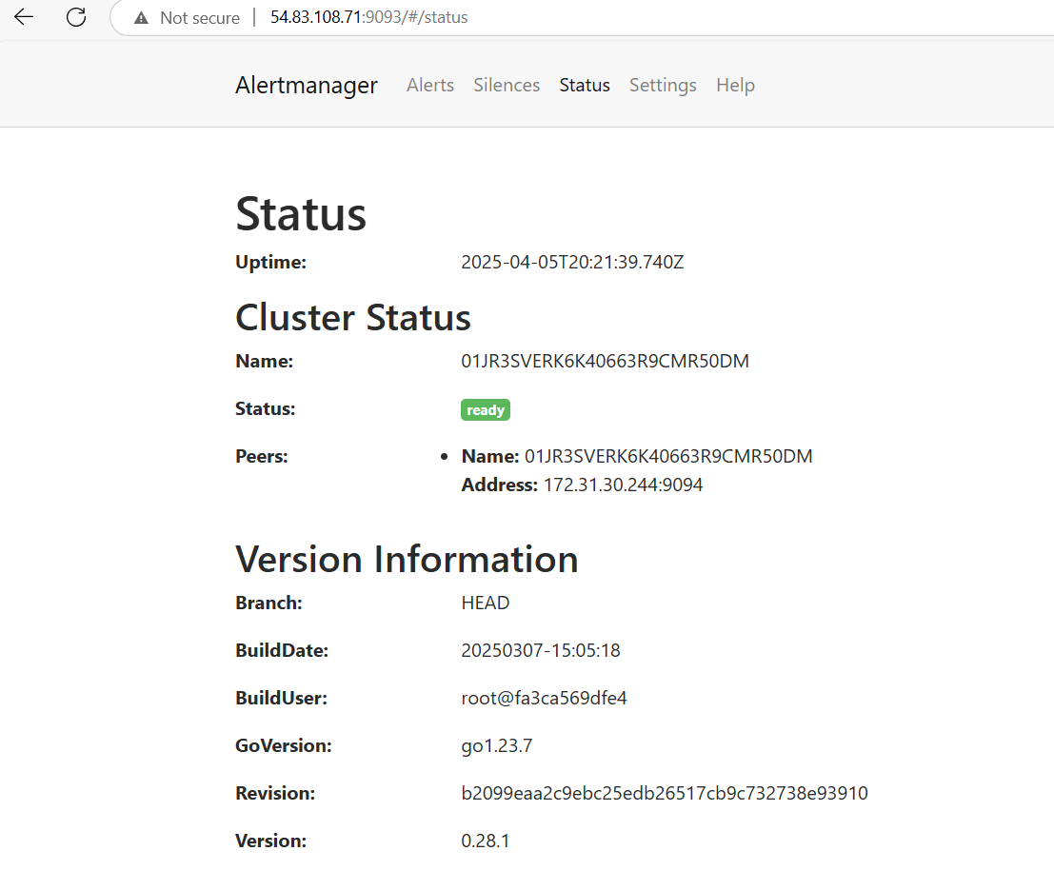

docker ps

docker stop 6594



I stopped my docker container to check whether my alert manager is triggering the mail.

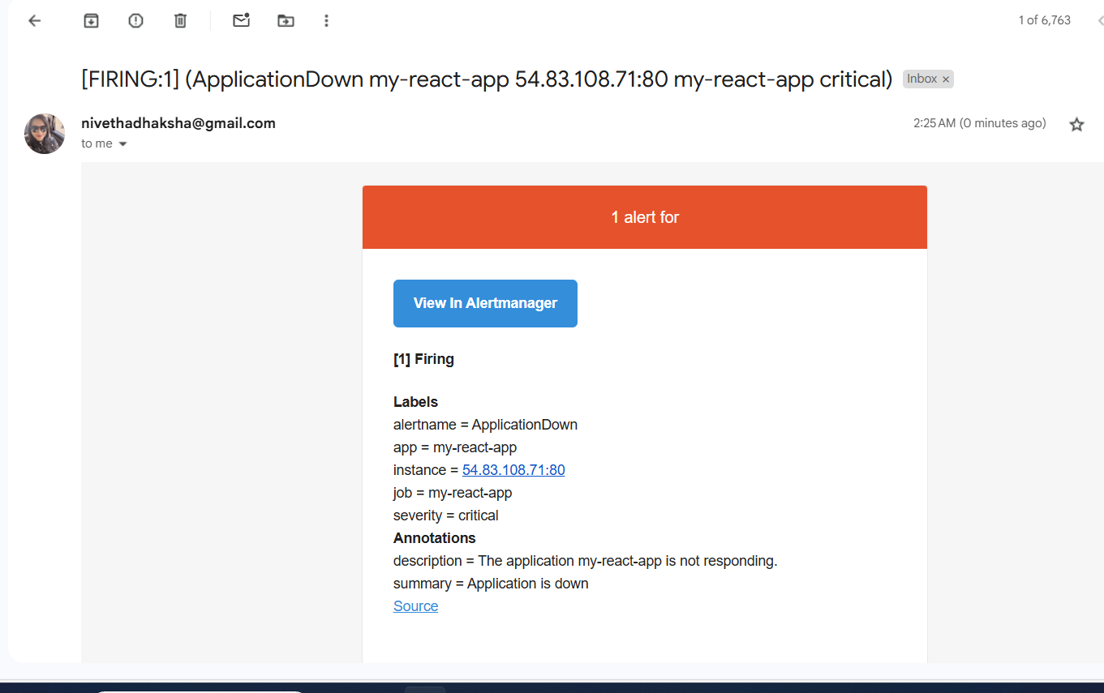

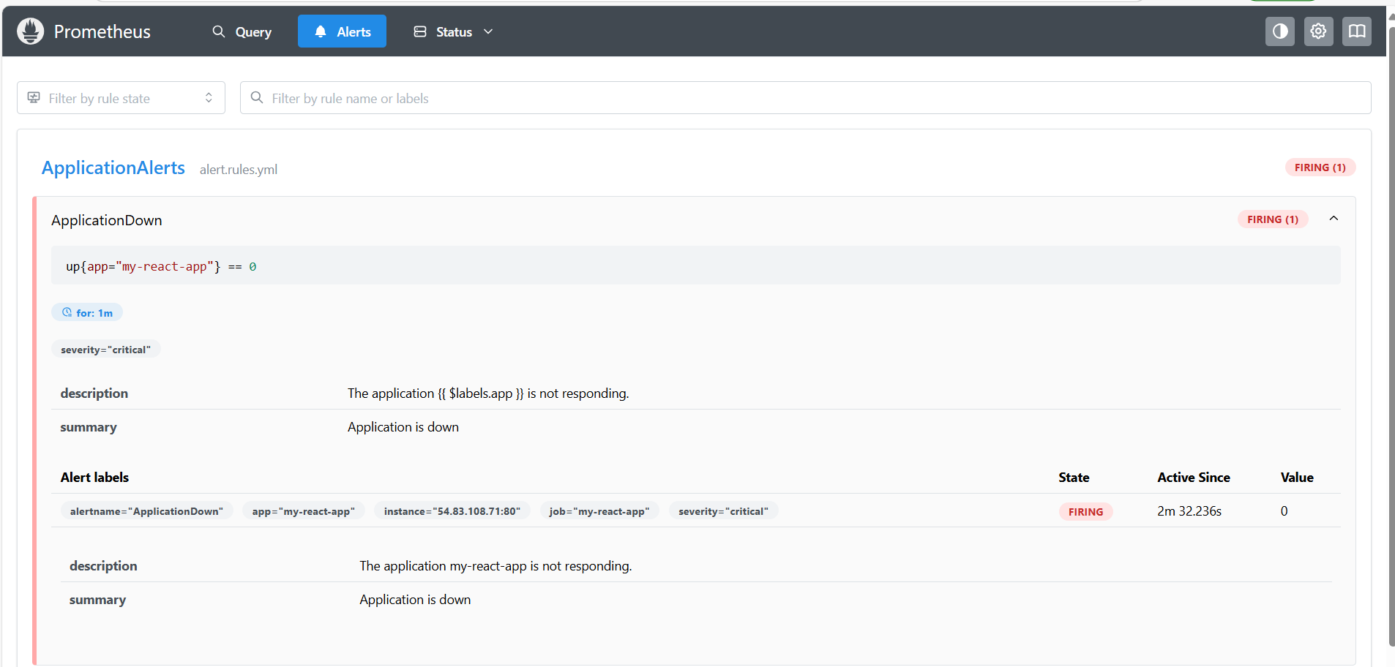

**Ports: Jenkins -8080**

**Prometheus – 9090**

**Node-exporter – 9100**

**Alert manager -9093**

**Checklist :**

1. **Jenkins (login page, configuration settings, execute step commands). - done**
2. **AWS (EC2 console, SG configurations) - done**
3. **Docker Hub repo with image tags - done**
4. **Deployed site page -done**
5. **Monitoring health check status – done (along with the mail trigger)**

**Optional**: Have installed Grafana as well for visualization

Visit the website [Download Grafana | Grafana Labs](https://grafana.com/grafana/download) to get the Grafana download link

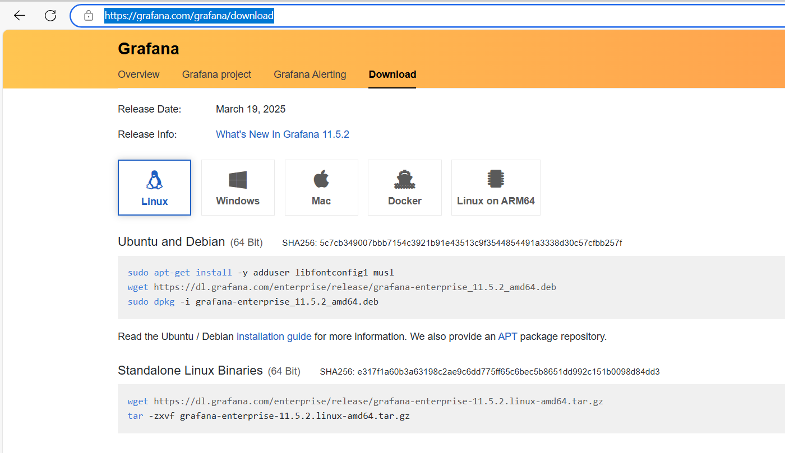

wget <https://dl.grafana.com/enterprise/release/grafana-enterprise-11.6.0.linux-amd64.tar.gz>

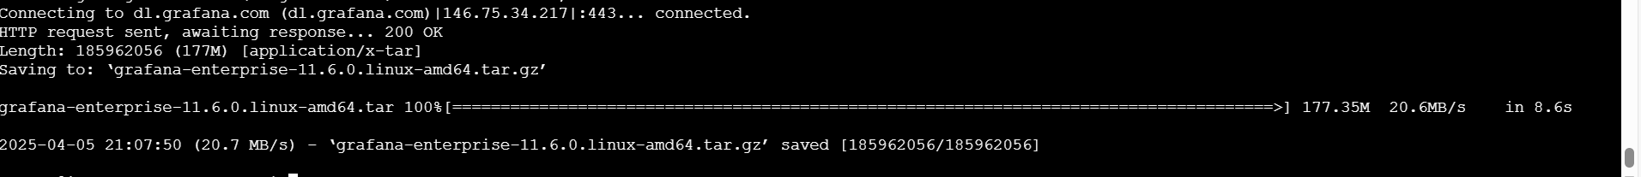

tar -xvzf grafana-enterprise-11.5.2.linux-amd64.tar.gz

ls

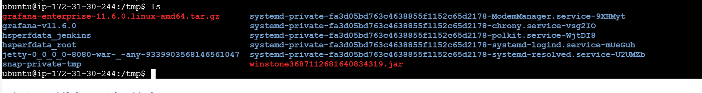

cd grafana-v11.6.0

cd bin

./grafana-server &

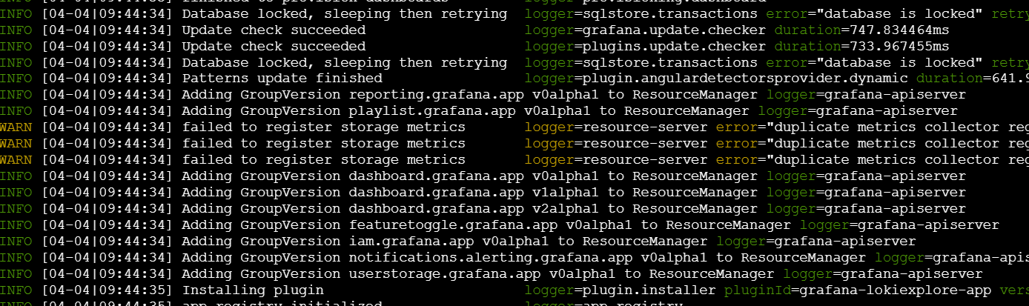

Logged out and logged back, so ip got changed

**Grafana port : 3000**

http://3.95.192.36:3000/

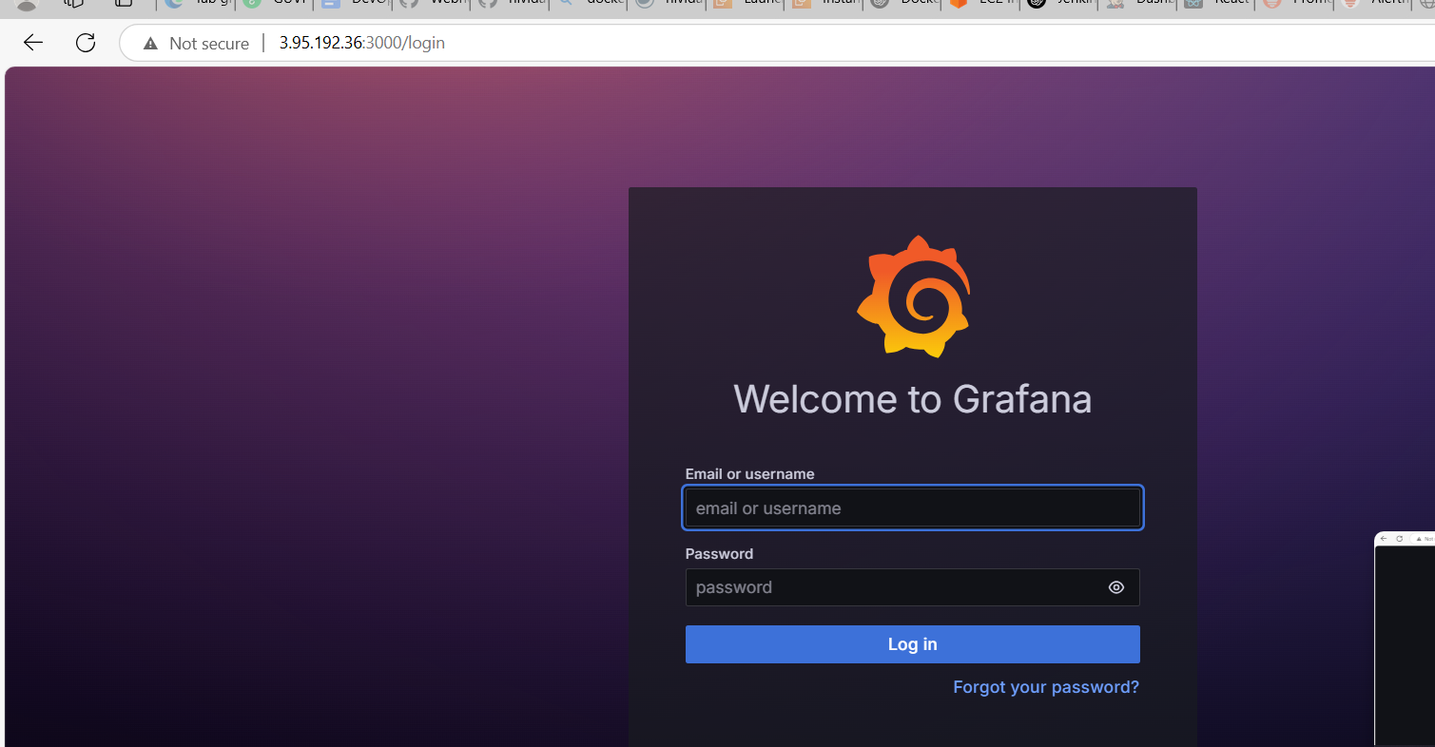

Login using credentials, use admin as the default password. Then change the pw.

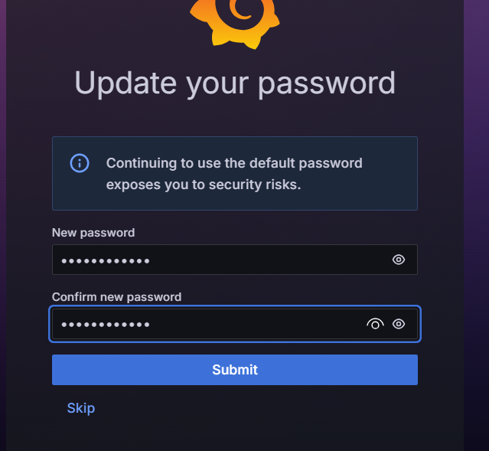

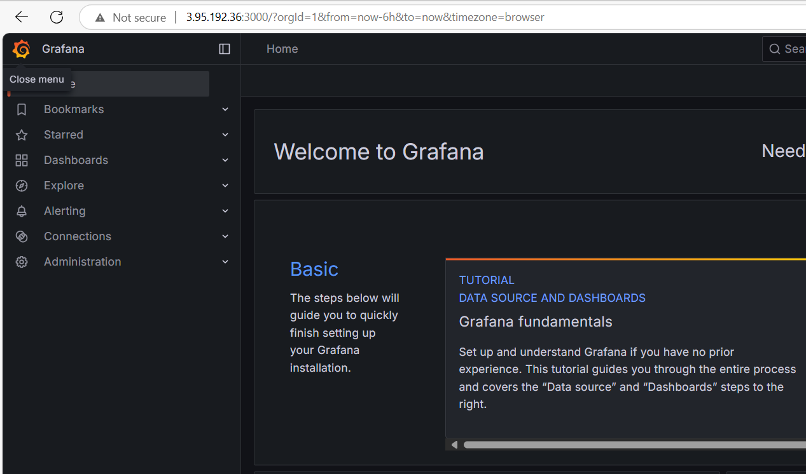

Add the data sources

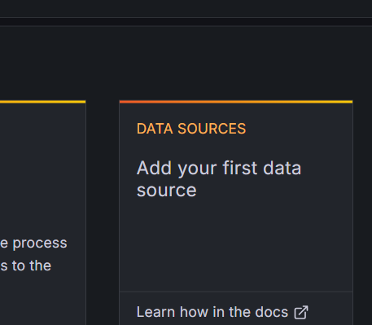

Choose Prometheus

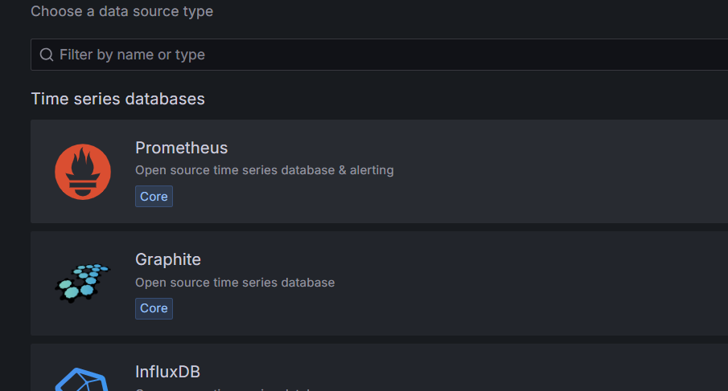

Give the Prometheus url

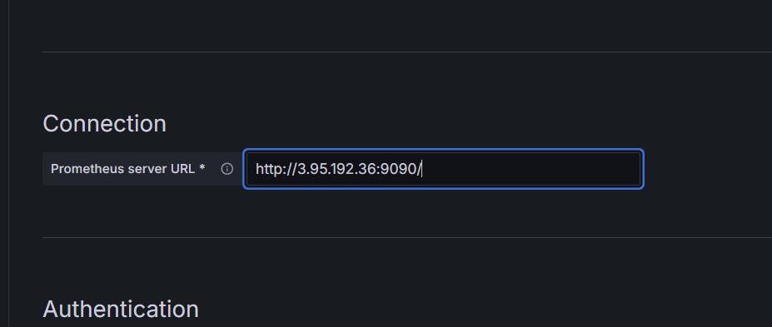

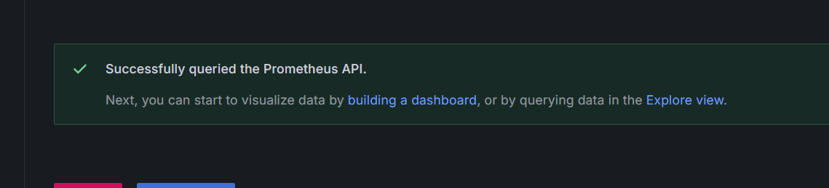

Then go to home> new dashboard or import dashboard

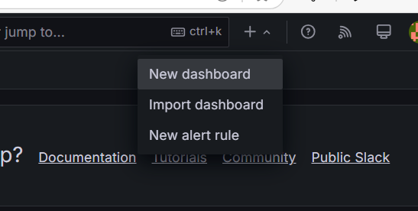

For import dashboard

Visit Grafana labs >> choose the desired dashboard and copy the id

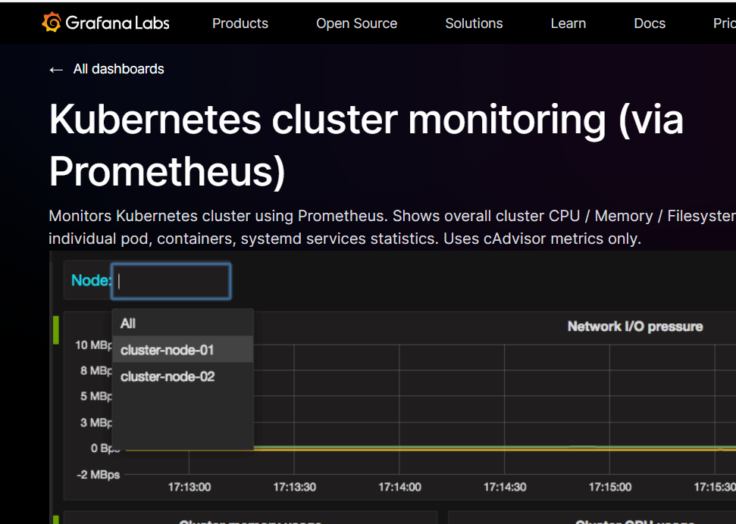

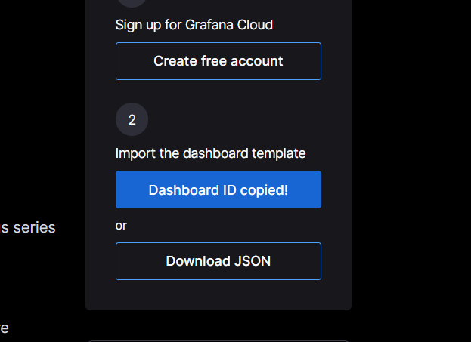

Paste the id and load

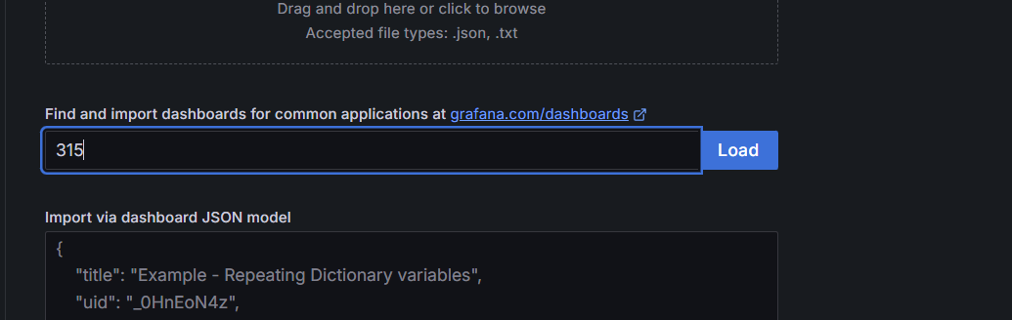

Set the query to view the dashboard

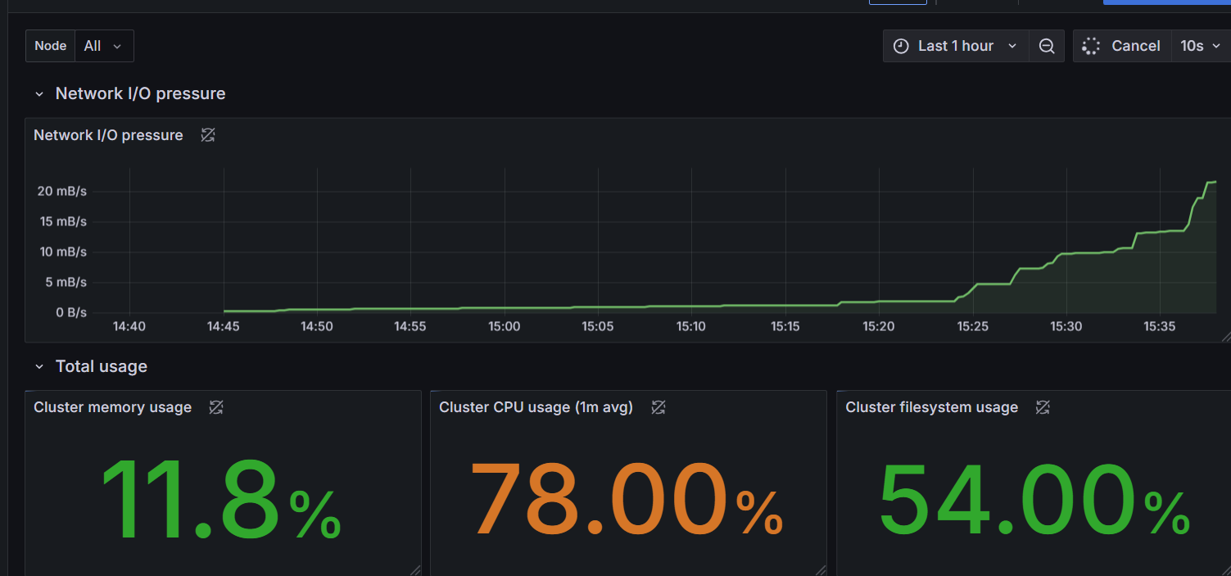

Explore different virtualization options

